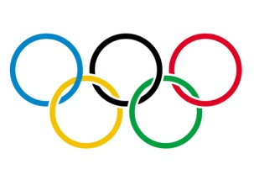
Olympic Winter Appreciation Week
Feb 18th-21st 2014

Tuesday Feb. 18th…………………………Favorite “Sport” Day
(Wear your favorite jersey, T-shirt, hat PJ’s)

Wednesday Feb. 19th………………………..Olympic Rings Day
K-1 wear Yellow
2-3 wear Black
Gr.4 wear Green
Gr. 5 wear Blue
Gr. 6 wear Red

Thursday Feb. 20th…………………………..School Colour Day
(Principal’s Cup @SC Arena Noon Grades 3-6)

Friday Feb.21st………………………………….Team Canada Day
(Wear Red & White in support of Team Canada)

Outdoor Activities K-2 Morning Sliding, Snowshoeing, Hockey
Outdoor Activities 3-6 Afternoon Sliding, Snowshoeing, Hockey

