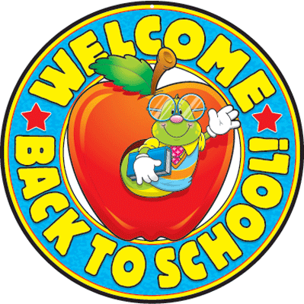
To: Parents & Guardians
Memo
From: NSEE
Date: June 25th, 2021
Re: Back to School (Staggered Entry)
In September, schools in ASD-N will be having a staggered entry. This will help students adapt to school routines and ease back into a regular schedule.

Please note:
- Half of our students will have their first day of school on Tuesday, September 7th and then stay home the following day.
- The other half will stay home on September 7th and have their first day of school on Wednesday, September 8th.
- Then all students will attend school together on Thursday, September 8th and Friday, September 9th.
- If your child’s name is not below, please contact the school.
- We scheduled siblings to have the same start date. If we have forgotten someone, please contact the school.

Please consult the chart below to see when your child’s first day of school will be in September.
We will see you in September!
Grade 1
September 7th | September 8th
Hendrix | Hudson
Jorilynne | Camden B.
Charles | Nevaeh
Allie | Aaliyah
Bryar | Rosie
Makenna | Ava
Sheridan | Sophie

Kindergarten
September 7th | September 8th
Emma | Kadyn
Riley | Rhett
Kayden | Fox
Jorina | Lennex
Ryker | Landon
Jay | Ethan
Harrison | Raeyah
 | Ivalee
Grade 1/2
September 7th | September 8th
Kora | Canaan
Nelly | Brytan
Skye | Aiden
Taylor | Brighid
Daniel | Mandy
Leah
Emma
Rowen
Camden K.

Grade 3/4
September 7th | September 8th
Charlotte | Bobby
Zane | Brendon
Brynley | Aubree
Naelle | Lachlan
Daemon | Hudson
Buddy | Aydan
Jase | Bella
Annabel | Rylan
Malakai | Sofia
Lexi | Emmet

Grade 2 (French Immersion)
September 7th | September 8th
Carter | Mason
Halle | Maryn
Annie | Kahli-Rae
Thomas | Jared
Ainsley | Jase
Andrew | Ally
Emma | Charley
Piper | Euan
Grade 3/4 (French Immersion)
September 7th | September 8th
Olivia B. | Ryker
Adriana | Sterling
Vivienne | Olivia R.
Hayzen | Claire
Will | Jaxon
Davison | Rylie
Lawson | Asher
Carter

Grade 5 (French Immersion)
September 7th | September 8th
Danika | Olivia M.
Kali | Myles
Leslie | Rachael
Braelyn | Addison
Grade 5
September 7th | September 8th
Emily B. | Lilly
Vicki | Olivia M.
Donovan | Lynzi
Jackson | Skylar
Marissa | Heaven
Brody | Declan
Sophie
Grade 6
September 7th | September 8th
Bentley | Emma H.
Caden | Andrew
Izak | Cale
Drake | Grayson
Emmett | Emily
Quinn | Lexie
Steven | Sydney
Emma M. | Sahara
Kailynn | Addison
Teagan | Alianne

