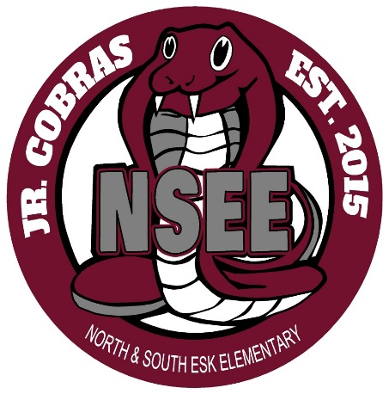

North & South Esk Elementary
School Supply List Grades K - 2

This year we will be collecting $50.00 for each student which will cover the cost of all school supplies.

The only items that your child will need to bring to school are the following:

Book Bag – large enough for their homework, lunch can and ski pants

Indoor Sneakers – sneakers that they are able to put on off themselves (Velcro)

Lunch Can and/or change purse

3 Boxes of Kleenex

Please send the money on the first day of school, with your child’s name clearly marked on the bag or envelope.

Thank you and have a great summer!

Primary Teachers

