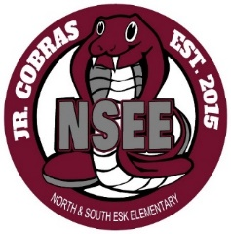

North & South Esk Elementary
School Supply List Grades K to 2

The only items that your child will need to bring to school are the following:

- backpack (large enough for their homework, lunch can and ski pants)

- indoor sneakers (sneakers that your child is able to put on and off themselves)

- lunch can

- one box of Kleenex

- a water bottle (just a reminder that we have no water fountains at NSEE anymore…there are just water bottle refill stations)

- a pair of headphones (these do not need to be expensive but no ear buds please)

We will be following the provincial guidelines for masks. If a mask order is in place, we may also require:

- two community face masks

- a mask container

Please label all items above.

This year we will be collecting $55.00 from each student to cover the cost of all school supplies. Please send the money on the first day of school with your child’s name clearly marked on the baggie or envelope.

Please check our Facebook page and/or webpage this summer for more updates.

Thank you and have a great summer! NSEE Staff

