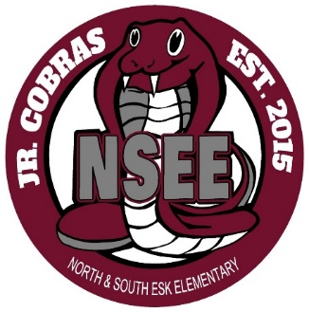

North & South Esk Elementary
School Supply List Grades K to 2

This year we will be collecting $50.00 from each student which will cover the cost of all school supplies.

The only items that your child will need to bring to school are the following:

- Backpack (large enough for their homework, lunch can and ski pants)

- Indoor Sneakers (sneakers that they are able to put on & off themselves and stay fastened)

- Lunch Can and/or change purse

- 1 Box of Kleenex

- Please label all items

Please send the money on the first day of school, with your child’s name clearly marked on the bag or envelope.

Thank you and have a great summer!

NSEE Staff

