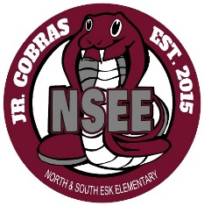
North & South Esk Elementary
School Supply List Grades 6

Fees:
- Agenda fee $10 (Please put this in a baggie with your child’s name on it)

Odds and Ends:
- Indoor shoes (sneakers for gym)
- Glue sticks (x3)
- Kleenex (x2 boxes)
- A protractor (You do not need a math set….only a protractor)
- White Labels (to put on duo tangs to label your name)
- Calculator (an inexpensive one- label this with your name)
- A package (5-10) of page protectors (clear plastic @ Dollar Store)
- Scissors (label it with your name)
- Ruler (clear/metric/not bendable- label this with your name)

Writing Materials:
- Pencil case
- Red Pens (x2)
- Pencils (x24)- Pack some and leave the rest at home to replenish as needed
- Pencil crayons
- Markers
- Erasers (white)
- Highlighters (x2)
- Pencil sharpener (with a cover)

Paper Products:
- 3 packages of loose leaf (not opened)
- 1 package of 4 scribblers (1 blue, 1 yellow, 1 pink, 1 green)
- 1 package of 1 cm grid paper- big squares. (No small grid paper)
- 2 binders (one inch thick each). (No zipper binders)
- 1 journal for Science. (hardcover composition book @ Dollar Store)
- 16 duo tangs (not vinyl please!)
Blue (x6) - Math
Green (x3) - Science
Yellow (x2) - French
Purple (x1) -Technology
Red (x2) - Social Studies
Black (x2) - Literacy (Please do not label these as they will be used for a Novel Study)

Thank you and have a great summer!

Grade 6 Teachers

