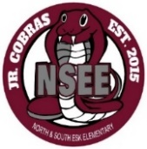

North & South Esk Elementary
School Supply List Grades 3 to 6

The only items that your child will need to bring to school are the following:

- backpack (large enough for their homework, lunch can and ski pants)

- indoor sneakers (sneakers that your child is able to put on and off themselves)

- lunch can

- two boxes of Kleenex

- a pencil case (it should be large enough for pencil crayon, a glue stick, etc.)

- a water bottle with your name on it (just a reminder that we have no water fountains at NSEE anymore…there are just water bottle refill stations)

We will be following the provincial guidelines for masks. If a mask order is in place, we may also require:

- two community face masks

- a mask container
Please label all items above.

This year we will be collecting $55.00 from each student to cover the cost of all school supplies. Please send the money on the first day of school with your child’s name clearly marked on the baggie or envelope.

Inexpensive headphones may have to be purchased for students. Some students may already have them from the previous year. If they are still working, they will be passed on to the next grade’s teacher. Your child’s homeroom teacher will let you know if a pair is required.

Please check our Facebook page and/or webpage this summer for more updates.

Thank you and have a great summer! NSEE Staff

