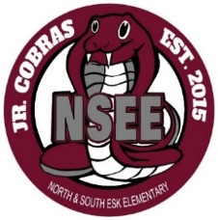

North & South Esk Elementary
School Supply List Grades 3-6

This year we will be collecting $50.00 for each student which will cover the cost of all school supplies. We will not be having a Student Agenda this year.

The only items that your child will need to bring to school are the following:

- Backpack (large enough for their homework, lunch can and ski pants)

- Indoor Sneakers (sneakers that they are able to put on/off themselves)

- Lunch Can and/or change purse

- Pencil Case (it should be large enough for pencil crayons, a glue stick, etc.)

- 2 Boxes of Kleenex

- Please label all items

*Inexpensive headphones may have to be purchased for students. Some students may already have them from the previous year. If they are still working, they will be passed on to the next grade’s teacher. Your child’s homeroom teacher will let you know if they are needed in September.

Please send the money on the first day of school, with your child’s name clearly marked on the bag or envelope.

Please check our school’s webpage and/or the NSEE Facebook page for updates on new health guidelines for Covid-19.

Thank you and have a great summer!

NSEE Staff

