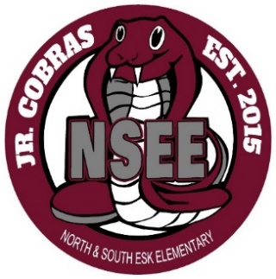

North & South Esk Elementary
School Supply List Grades 3-6

This year we will be collecting $60.00 for each student which will cover the cost of all school supplies and the NSEE Student Agenda.

The only items that your child will need to bring to school are the following:

- Backpack (large enough for their homework, lunch can and ski pants)

- Indoor Sneakers (sneakers that they are able to put on/off themselves)

- Lunch Can and/or change purse

- Pencil Case (for Grades 5 and 6 only)

- 2 Boxes of Kleenex

- 1 Pair of inexpensive headphones

- Please label all items

Please send the money on the first day of school, with your child’s name clearly marked on the bag or envelope.

Thank you and have a great summer!

NSEE Staff

