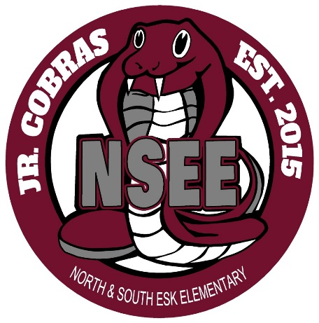

North & South Esk Elementary
School Supply List Grades 3-5

This year we will be collecting $60.00 for each student which will cover the cost of all school supplies and the Student Agenda.

The only items that your child will need to bring to school are the following:

Book Bag – large enough for their homework, lunch can and ski pants

Indoor Sneakers – Sneakers that they are able to put on/off themselves

Lunch Can and/or change purse

Pencil Case

3 Boxes of Kleenex

1 Pair of inexpensive Headphones

Please send the money on the first day of school, with your child’s name clearly marked on the bag or envelope.

Thank you and have a great summer!

Elementary Teachers

