NSEE Bass Fishing Family Night
2017
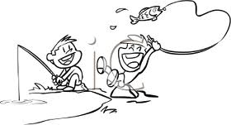

Dear Parent or Guardian:

As part of our Fishing Derby, NSEE is hosting an after school Bass Fishing Family Night on the Mighty Miramichi River Wednesday May 24th 2017 at 6:30 pm!

- I am asking parents to accompany their child/ren for this event. It will be the responsibility of the parent to drive your child or arrange a drive to our fishing destination.

- Destination: Bill Schenkels home/property in Whitney.

- I am asking that if you have the required fishing gear please bring it for the outing. I am also asking that if you have extra gear to loan please bring this along as there may be students without adequate equipment. Fishing license NOT required in tidal waters!

- We will meet at Bill Schenkels property on Schenkels Lane at 6:30 pm.

- NOTE: Family night subject to DFO rules on river closure. If the stretch of the river from the Mill Stream up is closed, family fish night will be cancelled.

Good luck Anglers!!

Questions or concerns please contact Jamie Henderson at NSEE 836-7010

