B | I | N | G | O
Go on a family walk. | Help make Lunch/Supper. | Drink 6 to 8 glasses of water in a day. | Put on some music and dance for five minutes. | Clean up your room before bed.
Play charades. Include some actions to demonstrate emotions. | Make a list of 5 things that you are grateful for. Share with someone. | Draw a picture of a PE Game you would like to play when we get back. | Do 10 minutes of Yoga. (Link at bottom) | 10 Jumping Jacks  10 Push ups  10 Burpees
Play outside for at least 15 minutes. | Have a Family Board game day/night. | FREE | Do 10 min of Just Dance or Go noodle (Links at the bottom) | Call a friend or family member to check in.
Build a fort. Inside or outside. | Skip 3 laps around your house. | Make yourself or your family a healthy snack. | Make a card for someone in your family. Give 2 compliments. | Call a relative to get a recipe for their famous dish that you love!
Walk up and down your stairs for 5 minutes. | Win 10 games of Rock, Paper, Scissors. | Pick your favorite activity and do it again. | Have a crab walk race with a family member. | Get 60 minutes of Physical Activity in a day. (Can be broken up throughout the day)
Jr. Cobra Bingo 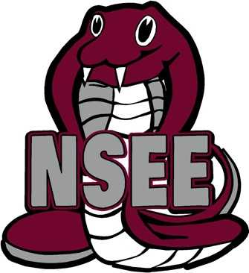
Mark with an “X” the different activities you complete over the course of the week. How many different variations of BINGO can you get?
Yoga Videos
https://www.youtube.com/user/CosmicKidsYoga
Dancing/Movement Options: Go noodle or Just Dance for Kids
https://family.gonoodle.com/
https://www.youtube.com/watch?v=ziLHZeKbMUo (Just Dance – Move It, Move It)
https://www.youtube.com/watch?v=sHd2s_saYsQ (Kidzbop Dance/Sing)

