Day 9 – Home learning for K-2
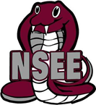

No technology options | Technology Needed
Help a neighbor or friend with some fall clean-up! | This week on Go noodle try out  Dynamite
Read a book while doing a wall sit. | How about a Cosmic kid’s yoga adventure? Follow the link for a great adventure.  Spider Power Yoga
Spring into Action: Find someone to do 20 jumping jacks with you. | Try out a new workout today. You can choose from exercises or dance moves in this video. Dance or Move Tabata 1
Did you know donuts have ~280 calories? Jog in place for a 280 count. | If you are a gamer, you may enjoy this video game workout “A crocodile Adventure”  A crocodile adventure

