Welcome to the month of June and our 9th week of Home Learning! We are certainly enjoying some beautiful weather. I hope you are taking advantage of all nature has to offer. There are learning opportunities all around us everyday.
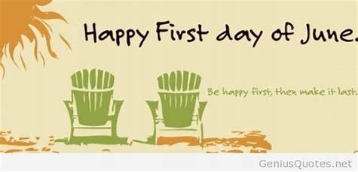
Remember, you can visit Mrs. Mutch’s teacher page for Math, Miss Downey’s for Wellness, Miss Mountain’s for First Nations Learning and Mrs. Estys’ has lots of learning activities too.
Find a comfy spot outside and read 30 minutes a day... 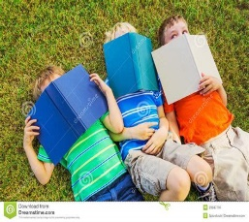
Dreamstime.com
After reading each day, choose a reading activity from the Choice Board:
Interesting Fact  Explain the most interesting thing you learned from the reading and why it stood out for you? | What I Learned  What are 2 new pieces of  information that you learned from your reading? | Opinion  What is your opinion on the topic you read about? How do you feel about the issue?
Questions  After reading the article, passage, or book, what are 2 questions you still have that you could research to find more about? | Visual Images  Choose a diagram, map, chart, graph or image that is important to the text. Draw the image and explain why it is important to the text. | Summary  Use Who, What, Where, When and Why to summarize what you read.

Literacy & Social Studies Connection
Writing Challenges for this week…

- Choose and write about five items you would include in a time capsule that future archaeologists will use to tell the story of how you lived in 2020 and what was important to you and your family.
- Interview someone in your family or your community. Create a list of 5-10 questions to ask that person that will let them tell a story about the past. When you are done the interview review your notes and answer the following question: What did the person tell you about the past that connects to life today?
- virtualmuseum.ca is the Virtual Museum of Canada. Includes an Image Gallery showcasing thousands of artefacts (paintings, photos, objects).
http://www.museevirtuelvirtualmuseum.ca/Search.do?ig=on&lang=en

Choose 5 artefacts from a museum site and analyse the artefacts by answering the following questions:
- What does it look like? (colour, size, shape, complete, part, etc.)
- How is it made? (handmade, machinemade)
- What was it made for? (Who used it? Is it decorated? Is it similar to anything you know today?)
- How important was it? (to the maker and to the user)
- From what era was it? (What technology was used?)

Ongoing Science and Cross-Curricular learning:
Students can continue to use the Science Journal Ideas from week 5. Record in your journal something you have enjoyed about nature this week.
The following link has weekly learning activities that our District- Stem North-has developed for our students:
This week find out about fiddleheads and Dandelion Lemonade!
http://stemnorth.nbed.nb.ca/sites/stemnorth.nbed.nb.ca/files/doc/y2020/May/asdn_weekly_steam_issue_9_2.pdf

French Learning:
We have been learning about food the last few weeks in our Home Learning. Use the vocabulary from the last few weeks on my Teacher Page to create a Menu in French. You can name your restaurant or café and choose the items you want on your menu. Be creative!
If there are some words you do not know you could look them up on the internet (wordreference.com is the one we use in class), in a French-English dictionary or ask someone that may know.
If you have any questions or concerns I can be reached on our NSEE Grade 5 Facebook Page or by e-mail at luticha.taylor@nbed.nb.ca
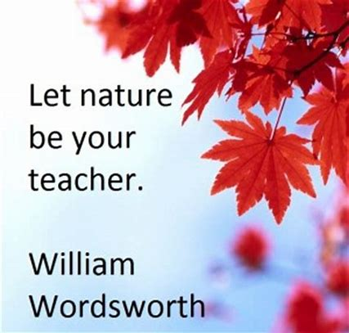Bing images
Enjoy nature & enjoy learning!
Mrs.Taylor

