How is it possible it is the last week of May and our 8th week of Home Learning? There are so many outdoor learning opportunities all around you. Get outside and explore! What would you like to learn about this week in an “outdoor classroom”?
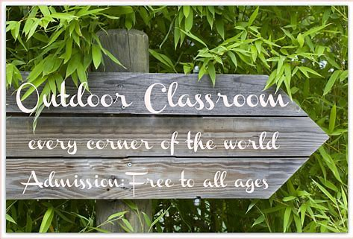
https://www.magicalmovementcompanycarolynsblog.com/2016/02/outdoor-classroom-are-your-montessori.html
Remember, you can visit Mrs. Mutch’s teacher page for Math, Miss Downey’s for Wellness, Miss Mountain’s for First Nations Learning and Mrs. Estys’ has lots of learning activities too.
Find a comfy spot outside and read 30 minutes a day... 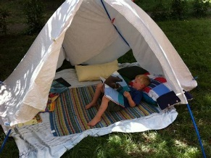
After reading each day, choose a reading activity from the Choice Board:
Fiction Reading Response
What point of view is the story written in? How do you know? | Record one quote from the story that you really found interesting to you, made you think, or you really enjoyed. Why did you choose that quote? | Record three unfamiliar words that you came across while reading. What did you think each word meant? Why?
Record the title of your story. Why do you think the author chose this title? | What do you think may have inspired the author to write this particular story? Why? | What is the setting of the story? How does it affect the plot?
What is the theme of your story? How do you know? | Choose a character in your story. Write down three adjectives that describe the character. | Think about how the story could have a different ending then write your alternate ending.
Writing Challenges for this week…
1) We have been working through the stages of the writing process to create an opinion piece of writing:
Choose a topic
Plan using a graphic organizer
Write an introduction
Write a draft giving reasons and examples to support your opinion
This week, we will complete the opinion piece by writing a conclusion: https://www.youtube.com/watch?v=3Xo9C8BxgWE&feature=emb_rel_pause
Revise to make your writing better https://www.youtube.com/watch?v=6sZao2fUhSw
Edit to fix mistakes in spelling, capitalization and punctuation: https://www.youtube.com/watch?v=LSmjkSkaR70
You now have completed your opinion piece! Read it to someone.

2) Look out and up—are there any clouds today? Just stop and watch for a while. Can you describe their movement? Fast, slow, steady? Be creative—what other words or phrases could you use? Clouds can create pictures and stories in the sky. Can you see any shapes or images in the clouds? Do they stay the same, or change into something else? Write a story about the characters and pictures you can see.

Ongoing Science and Cross-Curricular learning:
Students can continue to use the Science Journal Ideas from week 5. Record in your journal something you have learned about this week from the great outdoors. Did you discover any animal homes or see any animals or changes in nature?
The following link has weekly learning activities and challenges that our District- Stem North-has developed for our students to access:
http://stemnorth.nbed.nb.ca/sites/stemnorth.nbed.nb.ca/files/doc/y2020/May/asdn_weekly_steam_issue_8.pdf
French Learning Sites:
The students are very familiar with the songs on the Sylvia Duckworth YouTube site. A new song to teach about the foods we eat is #9 on the list – Envoici, Envoila - Song by Alain le lait:
https://www.youtube.com/playlist?list=PL358891FD40D3E290
Following is a short video to help learn how to order food:

French Lesson 80 - At the fast food - Cafeteria Restaurant Ordering food + English subtitles:
https://www.youtube.com/watch?v=HBjphQXWtlE

If you have any questions or concerns I can be reached on our NSEE Grade 5 Facebook Page or by e-mail at luticha.taylor@nbed.nb.ca
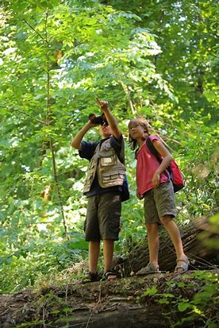Bing Images
Explore & enjoy learning!
Mrs.Taylor

