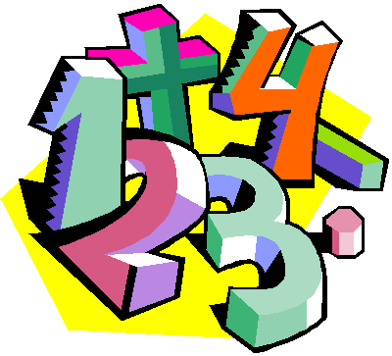
Suggestions for Home Learning Week 7 (May 18th to May 22th)
Grade 5 Math

 | Using No Technology | With Technology
Multiplication &  Division  Practice | Ideas to practice your Multiplication and Division Facts:  - Play Multiplication Snap with cards  - Use flash cards  - Make up 12 questions to solve  - Roll two dice and multiply the two numbers  Other link to practice at home:  https://www.weareteachers.com/22-fun-hands-on-ways-to-teach-multiplication/ | Study your math facts from 1 to 9.  You should be able to do 12 questions in one minute.  www.multiplication.com  https://www.abcya.com/search/?term=multiplication&type=game&id=0  https://www.abcya.com/games/number_ninja_multiples
Math  Review | Review front-end rounding and multiplication:  30 x 50 = 1500 (The basic fact is 3 x 5 =15)  7 x 80 = 560 (the basic fact is 7 x 8 = 56) | Some other sites to use to review all math concepts covered this year include:  www.dreambox.com/at-home  https://on.mathgames.com/grade5  https://www.iknowit.com/
Something New | This week we will continue to work on Multiplication of large numbers.  Please look at the duo tang I sent home last week for Home Learning  At the top of the sheets, you will find a “Quick Review”. Read this first and them complete your sheets on Multiplication. I also added some sheets of my own that may help explain this concept.  There are 6 sheets on multiplication starting on page 34.  This outcome needs lots of practice.  One hint is to use a calculator to check your work. If it is wrong…try it again. | Here are some videos to help you learn this new concept.  Basic Stuff: https://www.khanacademy.org/math/arithmetic-home/multiply-divide/place-value-area-models/v/more-ways-to-think-about-multiplying  Estimation: https://www.khanacademy.org/math/in-in-class-6th-math-cbse/x06b5af6950647cd2:in-in-6th-know-numbers/x06b5af6950647cd2:estimating-operation-of-numbers/v/multiplying-whole-numbers-and-applications-4  http://www.learnalberta.ca/content/me5l/html/Math5.html (Choose Multiplication of Whole Numbers)  A Bit Harder: https://www.khanacademy.org/math/arithmetic-home/multiply-divide/place-value-area-models/v/4-by-1-multiplication-with-grid
A Bit  of  Fun | See “Nature Ninja” math activity (Week 4) on the next page. | If you want to explore your creative math side:  https://www.scholastic.com/teachers/articles/teaching-content/craft-projects-math-class/
- For extra practice sheets, please check out the duo tang that I sent home in your bag this week
- If you still want some more, check out this site: https://www.k5learning.com/free-math-worksheets/fifth-grade-5

