Well, here we are in our 7th week of Home Learning. The month of May is passing by quickly! I hope you are all keeping active and enjoying all that Spring has to offer in our beautiful community.
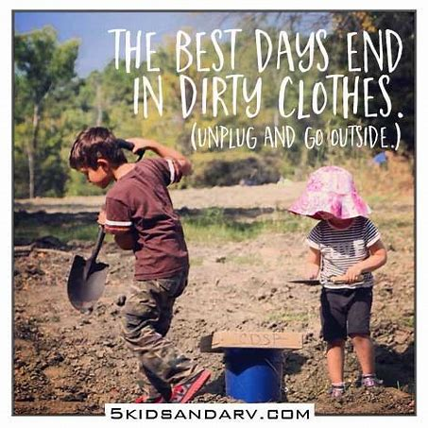
Remember, you can visit Mrs. Mutch’s teacher page for Math, Miss Downey’s for Wellness, Miss Mountain’s for First Nations Learning and Mrs. Estys’ has lots of learning activities too.
Find a comfy spot outside and read 30 minutes a day...
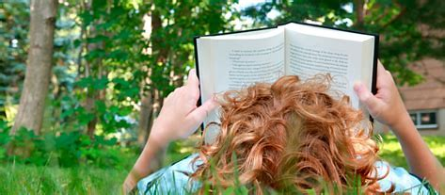 Bing images
After reading each day, choose a reading activity from the Choice Board:
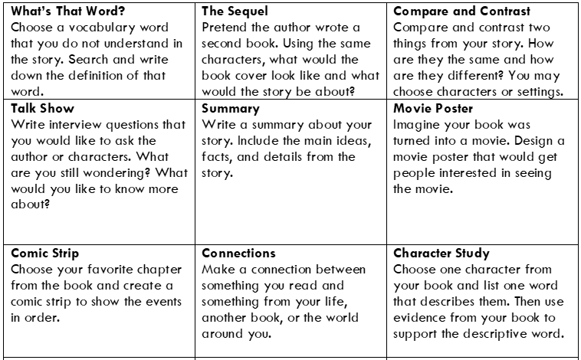
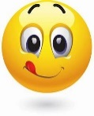Yummy Writing Challenge for this week…
This week’s writing genre focuses on opinion writing. See resources and digital lessons below.

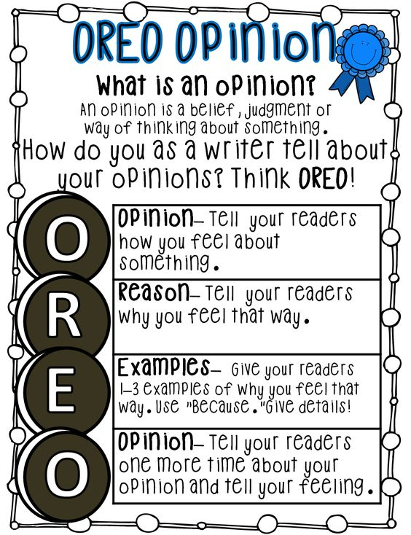

View the following three teaching videos on how to write an opinion piece:
- Episode 1: What is an opinion piece?
Link: https://www.youtube.com/watch?v=KEK2oGBSsHk

- Episode 2: Choosing an opinion writing topic
Link: https://www.youtube.com/watch?v=qv4rHG6rrr8

- Episode 3: Making an opinion writing plan
Link: https://www.youtube.com/watch?v=7kYtkqfXMOg

Now choose an opinion writing topic and use the graphic organizer below to make your opinion writing plan.
Opinion Writing Graphic Organizer

REASON #1  Topic | REASON #2
REASON #3 | REASON #4

Ongoing Science and Cross-Curricular learning:
Students can continue to use the Science Journal Ideas from week 5 to record observations and anything that interests them.
The following link has fun weekly learning activities and challenges that our District- Stem North- has developed for our students to access and enjoy:
http://stemnorth.nbed.nb.ca/sites/stemnorth.nbed.nb.ca/files/doc/y2020/May/asdn_weekly_steam_issue_7.pdf

French Learning Sites:
The students are familiar with the song ‘J’aime les fruits’ by Alain le lait- a song we sing in class to learn about the different fruits.
https://www.youtube.com/watch?v=nJ03KjwiIVM Youtube- Song & Animation by Alain le lait
https://www.youtube.com/watch?v=d5U4kDDBCVA Youtube- Song & Animation by Alain le lait- to learn about Breakfast foods in a song.
Listen and repeat to learn new vocabulary: Apprendre les aliments
- Learn about food
https://www.youtube.com/watch?v=Fs9NSNJVMEE ekidsChannel on YouTube-
Draw and label some pictures of some foods you have learned about.

If you have any questions or concerns I can be reached on our NSEE Grade 5 Facebook Page or by e-mail at luticha.taylor@nbed.nb.ca
Keep on learning!
Mrs.Taylor

