Welcome Back Grade 5 Students and Parents! Wow! Week 6 of our Home Learning experience. I am hoping everyone is getting outside to explore, enjoy and learn from nature all around us.
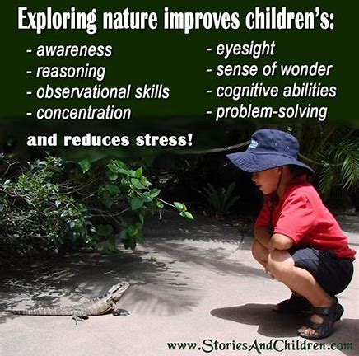
Remember, you can visit Mrs. Mutch’s teacher page for Math, Miss Downey’s for Wellness, Miss Mountain’s for First Nations Learning and Mrs. Estys’ has lots of learning activities too.
Find a comfy spot and read 30 minutes a day...
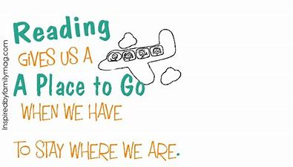

Sequencing  Write 5 events from your book. Sequence them by putting them in the correct order. | Predicting  Before you start the next chapter of your book, make a prediction about what you think will happen next. Then, after you read the chapter, tell whether your prediction was correct. | Monitoring  As you read look for tricky words. Write them down. Then, use a dictionary to find out how to say them and what they mean. Write down the definitions.
Questioning  Before you read the next chapter, write 5 questions about your book. Keep reading and write the answers when you find them | Your choice  Choose an activity that will help you practice reading strategies. Write about what you did. | Visualizing  Choose a part of the book where the author used words to create a picture in your mind. Write the author’s description and draw a picture of what you visualize.
Making Inferences  Think about the title of your book. Why do you think the author gave the book this title? Use evidence from the book to support your answer. | Making Connections  What happened in the book that you can relate to your life? Write about two connections you can make to the book. | Retelling  When you finish reading the book, retell the story in your own words. Write the important events. Be sure to include the beginning, middle and end.
After reading each day, choose 1 box from the Literacy Learning Choice Board :

Creative Writing Challenge
Create an acrostic poem to give to someone special.
To create an acrostic poem, follow these five easy steps:
- Decide what to write about.
- Write your word down vertically. MOTHER/GRAMMY/FATHER/UNCLE/FRIEND
- Brainstorm words or phrases that describe that person.
- Place your brainstormed words or phrases on the lines that begin with the same letters.
- Fill in the rest of the lines to create a poem. It does not have to rhyme!

You can also click on the link below to view a short video explaining acrostic poems.

https://www.youtube.com/watch?v=ybexYTzmZ5Y

Ongoing Science and Cross-Curricular learning:
Students can continue to use the Science Journal Ideas from my Teacher Page to record observations and things that interest them. Share your observations with someone!
The following link has fun weekly learning activities and challenges that our District- Stem North- has developed for our students to access and enjoy:
http://stemnorth.nbed.nb.ca/sites/stemnorth.nbed.nb.ca/files/doc//y2020/May/asdn_weekly_steam_issue_6.pdf

French Learning Sites:
The students are very familiar with the songs on the Sylvia Duckworth YouTube site. They can continue to watch and sing along with the videos to practice French at home:
https://www.youtube.com/playlist?list=PL358891FD40D3E290
Song # 3 on the list is the song “Lunettes de soleil” by Gregg LeRock - Sylvia Duckworth.
A good site to find some French books to read along with is…

“BookBox.com”- Rosa Goes to the City : Learn French with Subtitles - Story for Children

https://www.youtube.com/watch?v=Y-JBM23zThg

If you have any questions or concerns I can be reached on our NSEE Grade 5 Facebook Page or by e-mail at luticha.taylor@nbed.nb.ca
It is great to see some of the activities you have been doing at home on our NSEE Grade 5 Facebook Page! Thank you to Abbi, Josephine, Riley & Mya for sharing their interesting projects!
Mrs.Taylor

