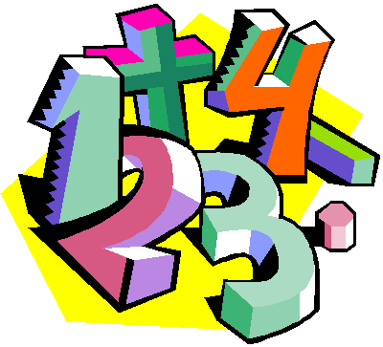
Suggestions for Home Learning Week 6 (May 11th to May 15th)
Grade 5 Math

 | Using No Technology | With Technology
Multiplication &  Division  Practice | Ideas to practice your Multiplication and Division Facts:  - Play Multiplication Snap with cards  - Use flash cards  - Make up 12 questions to solve  - Roll two dice and multiply the two numbers  Other link to practice at home:  https://www.weareteachers.com/22-fun-hands-on-ways-to-teach-multiplication/ | Study your math facts from 1 to 9. You should be able to do 12 questions in one minute.  www.multiplication.com  https://www.abcya.com/search/?term=multiplication&type=game&id=0  https://www.abcya.com/games/number_ninja_multiples
Math  Review | Adding and Subtracting Review:  This week, we will review how to add and subtract, but this time we will be working with decimals. Please complete pages 86 to 47 (Yes that is correct although it sounds strange).  Make sure to line up your numbers so the decimal point is at the same place. Grid paper will also help you keep everything organized. | Please do the work outlined in the section here  Some other sites to use to review all math concepts covered this year include:  www.dreambox.com/at-home  https://on.mathgames.com/grade5  https://www.iknowit.com/
Something New | This week we will start to work on Multiplication. Please have a look at the duo tang I sent home last week for Home Learning  At the top of the sheets, you will find a “Quick Review”. Read this first and them complete your sheets on Multiplication.  Sheets for Multiplication begin on Page 34 in our Home Learning duo tang. | This week we will start to work on multiplication. I sent home sheets in your Home Learning duo-tang.  Here are a few videos that might help.  Basic Stuff: https://www.khanacademy.org/math/arithmetic-home/multiply-divide/place-value-area-models/v/more-ways-to-think-about-multiplying  Estimation: https://www.khanacademy.org/math/in-in-class-6th-math-cbse/x06b5af6950647cd2:in-in-6th-know-numbers/x06b5af6950647cd2:estimating-operation-of-numbers/v/multiplying-whole-numbers-and-applications-4  http://www.learnalberta.ca/content/me5l/html/Math5.html (Choose Multiplication of Whole Numbers)  A Bit Harder: https://www.khanacademy.org/math/arithmetic-home/multiply-divide/place-value-area-models/v/4-by-1-multiplication-with-grid
A Bit  of  Fun | See “Nature Ninja” math activity (Week 3) on the next page. | Create your own math board game project:  http://www.imater.org/ourpages/auto/2015/5/18/40623584/Create%20a%20Math%20Board%20Game%20Project.pdf
- For extra practice sheets, please check out the duo tang that I sent home in your bag this week
- If you still want some more, check out this site: https://www.k5learning.com/free-math-worksheets/fifth-grade-5

