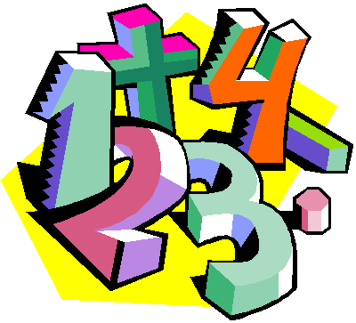
Suggestions for Home Learning Week 5 (May 4 to May 8th)
Grade 5 Math

 | Using No Technology | With Technology
Multiplication &  Division  Practice | Ideas to practice your Multiplication and Division Facts:  - Play Multiplication Snap with cards  - Use flash cards  - Make up 12 questions to solve  - Roll two dice and multiply the two numbers  Here is a link to some awesome hands on ideas to make and learn your facts at home.  https://www.weareteachers.com/22-fun-hands-on-ways-to-teach-multiplication/ | Study your math facts from 1 to 9. You should be able to do 12 questions in one minute.  www.multiplication.com  https://www.abcya.com/search/?term=multiplication&type=game&id=0  https://www.abcya.com/games/number_ninja_multiples
Math  Review | Mental Math Review:  Practice multiplying larger nice numbers ending in zero.  30 x 40 = 1200  Whole Number Review:  Can you find examples of large numbers in a newspaper or magazine? Practice reading the number aloud and writing it in expanded form.  32 486 = thirty-two thousand four hundred eighty six | A great website to use is Dreambox to review all math concepts covered this year.  www.dreambox.com/at-home  Another website to review all Grade 5 Math outcomes is:  https://on.mathgames.com/grade5
Something New | This week we will continue to work on fractions and decimals and have some time to work on the sheets I sent home in your Home Learning duo-tang.  At the top of the sheets, you will find a “Quick Review”. Read this first and them complete your sheets on Fractions and Decimals. | This week we will continue to work on fractions and decimals and have a chance to work on the sheets I sent home in your Home Learning duo-tang.  Here are few videos that might help.  Decimal Review: https://www.khanacademy.org/math/arithmetic/arith-decimals/arith-review-add-decimals/v/introduction-to-adding-decimals-tenths  Fraction Review: https://www.khanacademy.org/math/arithmetic/fraction-arithmetic/arith-review-fractions-intro/v/cutting-shapes-into-equal-parts
A Bit  of  Fun | See “Nature Ninja” math activity (Week 2) on next page.  Or  Check out these paper 3D shapes to make at home.  https://teachbesideme.com/3d-paper-shapes/ | Check out these cute Fractions Flowers:  https://teachbesideme.com/fraction-flowers/  You can use your lego to create multiplication towers:  http://www.navigatingbyjoy.com/2014/03/02/make-multiplication-tower/
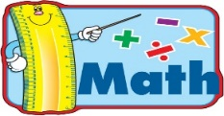
- For extra practice sheets, please check out the duo tang that I sent home in your bag this week

