Happy May Grade 5 Students & Families!
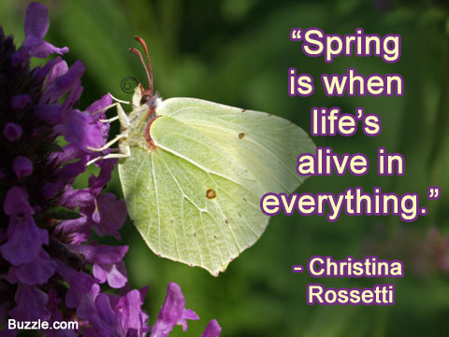
The signs of Spring are everywhere and we welcome them. I hope you are getting outside often to enjoy some fresh air and our beautiful surroundings.
Remember, you can visit Mrs. Mutch’s teacher page for Math, Miss Downey’s for Wellness, Miss Mountain’s for First Nations Learning and Mrs. Estys’ has lots of learning activities too.
Keep calm and read 30 minutes a day...
After you have finished your reading each day, choose one of the boxes on the Reading Response Choice Board below:

Reading Response Choice Board: Using the book that you are reading choose one of the options on the choice board to respond to each day.
B-M-E  Write 3 paragraphs summarizing important events that occurred at the Beginning (paragraph 1), Middle (paragraph 2), and End (paragraph 3) of the story. | 5 Finger Retell  Use the five –finger- retell to write 3 paragraphs about a story.  Paragraph 1- characters  Paragraph 2-setting  Paragraph 3 –the problem and how it was solved. | S-W-B-S (Somebody Wanted But So),  Somebody- Who is the story about?  Wanted- What did the character want?  But- but what happened?  So- So how did it end? What happened next?
Character Traits  Describe one of the characters in the story by giving examples of a character trait s/he exhibits.  Ex: brave, generous, thoughtful, determined, cunning.  Use examples from the story. | I Poems  Write a poem from the character’s point of view using some of the following sentence stems:  I am… I pretend…  I wonder… I feel…  I hear… I worry…  I see… I cry…  I want… I dream… | Alternate Ending  Think of a different way the story could have ended. Write a paragraph that describes what could have happened and what the consequences would have been.

Literacy & Social Studies Connection- Students can use the link below(Click Here) to read the reading with someone at home. The link is designed to help students find out more about the contributions and inventions of First Nations to society. Pictures can be discussed and printed off to color as well.
Title: Claire and her Grandfather (Click Here)

Writing Ideas:
As the weather gets nicer, there are several spring activities that you can do outdoors. Choose a topic from the list below or select your own topic and write a piece of procedural writing giving instructions on how to do, make, or be your topic.
Text Structure for Procedural Writing:
Purpose: To provide instructions about how to make, do or be something:
Do | How to Make | How to Be a
plant a flower | a garden | good friend
play hopscotch | a kite | soccer player
care for a pet | a bike Ramp | gymnast
go fishing | a birdhouse | good student
fly a kite | a bird Feeder | dancer
skip rope | a sandwich (choose your favourite sandwich) | at home helper at your age
ride a bike | a bed | good pet owner

Try to include the following in your procedural writing:
Title What are you writing about?
Goal What is going to be made or done?
Materials What is needed?
Steps How will it be made or done?
Exploration Activities
Write or make a letter/card/picture to drop off on the doorstep of a neighbour or family member. | Create a collage using items found outside. Use liquid glue to paste these items on heavy paper or cardboard. | Leaf Rubbing: Find a leaf and place white paper over it. Using wax crayons rub along the surface of the paper.

Ongoing Science and Cross-Curricular learning:
Students can continue to use the Science Journal Ideas from last week to record observations and things that interest them.
The following link has fun weekly learning activities and challenges that our District- Stem North- has developed for our students to access and enjoy:
http://stemnorth.nbed.nb.ca/sites/stemnorth.nbed.nb.ca/files/doc//y2020/Apr/asdn_weekly_steam_issue_5.pdf

French Learning Site:
The students are very familiar with the songs on the Sylvia Duckworth site. They can continue to watch and sing along with the videos to practice French at home:
https://www.youtube.com/playlist?list=PL358891FD40D3E290
Song # 17 on the list is the song “Louis la grenouille” by Matt Maxwell. It is about a frog “une grenouille” that loves to jump and dance. Have you seen any frogs yet this Spring?

If you have any questions or concerns I can be reached by
e-mail at luticha.taylor@nbed.nb.ca
It is great to see some of the activities you have been doing at home on our NSEE Grade 5 Facebook Page! Thank you to Abbi, Josephine, Riley & Mya for sharing their interesting projects!

Keep smiling & stay positive!
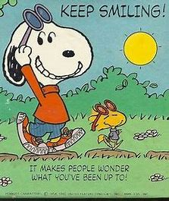
Mrs.Taylor

