Mrs. Sullivan’s Home Learning Choices Week Of May 25-29
Online or On Hand
Math | Math
Reflex Fact Practice  Reflex misses you  Try it again! https://www.reflexmath.com/  If you forget your login, email me and I will send it to you. | Target Number Card Game Materials: Deck of cards-face cards removed  Shuffle and deal out four cards for each player. Then flip the top card from the deck over in the center of the table. This is the Target Card.  Then, with the cards in your hands, you have to add or subtract to get to the target number. The goal is to do it with all four cards. If you get to the target number, you get a point. Then dump your cards and the target number and deal out again. Repeat it until someone gets to three points first
This Week’s Theme: Adding Numbers  Add Up Game https://www.teacherled.com/iresources/addition/addup/  Follow The Path Worksheet https://www.2nd-grade-math-salamanders.com/image-files/math-puzzles-printable-follow-the-path-3.gif  Puzzle Pics  https://www.mathplayground.com/puzzle_pics_addition.html  Addition Crossword Sheet  https://www.learn-with-math-games.com/support-files/math-addition-puzzles.pdf  Magic Triangle: https://www.mathplayground.com/magic_triangle.html  Magic Squares  https://www.transum.org/software/SW/magic_square/magic_square.asp  Find the Magic Squares  http://www.mathcats.com/explore/puzzles/magiccarpet1.html | This Week’s Theme: Adding Numbers
 | Can you find the missing numbers?  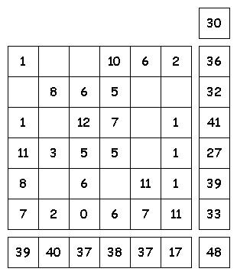  The missing numbers are from 0 to 12.  The numbers in each row add up to totals to the right.  The numbers in each column add up to the totals along the bottom.  The diagonal lines also add up the totals to the right. |  |  | Triangle Adding  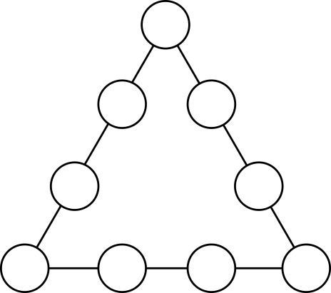  Put the numbers from 1 to 9 in the circles so that the sum of the numbers on each side of a triangle is the same. |  | Magic Square  15 is the magic number. Every row, column and diagonal adds up to it. Use the numbers from 1 to 9 only once on a 3 by 3 grid. Can you do it? |  | Legs in the Bus  1. There are 7 kids on a bus.  2. Each kid has 7 backpacks.  3. In each backpack, there are 7 big cats.  4. For every big cat there are 7 kittens  How many legs are on the bus, not counting the driver?  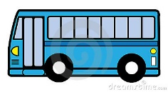
Literacy: Theme: New Brunswick | Literacy: Theme: New Brunswick
http://www.tourismnewbrunswick.ca/ Tourism NB  https://geology.com/canada/new-brunswick.shtml  NB Map  https://www.kidzone.ws/geography/newbrunswick/index.htm Britannica Kids Facts  https://www.cbc.ca/kidscbc2/the-feed/how-much-do-you-know-about-new-brunswick CBC Kids NB Quiz  https://www2.gnb.ca/content/gnb/en/gateways/about_nb/fun_facts.html NB Facts  https://mynewbrunswick.ca/nb-facts/ More NB Facts | Map skills  Get out a map of New Brunswick and try and find:  - Our capitol city-Fredericton  - Miramichi  - Where you live  - Where your grandparents live  - NSEE school |  | New Brunswick Checklist:  Where have you been?  -Mount Carleton  -Bouctouche Dune  -Grand Lake  -Bay of Fundy  -Grand Manan Island  -Hopewell Rocks  -King’s Landing  -Kouchibouguac  -Chaleur Bay  -Kingsbrae  -Restigouche  -St. John  Make a plan to visit one of these places. Do some research on what you might do when you get there.  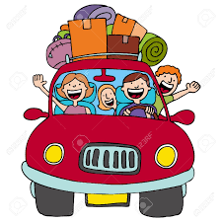 |  | New Brunswick Foods:  Which of the following have you eaten?  - Dulse  - Clams  - Lobsters  - Fiddleheads  - Blueberries  - Strawberries  - Potatoes  - Baked beans and Bread  - Salmon  - Maple Syrup  - Poutine  - Chicken fricot  Write a poem about the marvellous foods of New Brunswick! Write a story about eating your favourite on this list!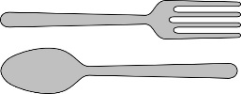 |  | New Brunswick Inventions:  - Blueprints  - Scuba Tank  - Fog Horn  - Snow Blower  - McFlurry  - Sardine Cans  Think of an idea for something that you would like to invent.  Draw it and label how it would work.
30 min Reading Ideas Word Work | 30 min Reading Ideas Word Work
https://www.abcya.com/grades/3/letters  https://www.thinkablepuzzles.com/hinkpinks/  http://www.thinkablepuzzles.com/commonyms/ | Spelling  Choose five new words to learn for spelling this week.  -Write your words with fancy writing  -Spell them out loud in your best grumpy teacher voice  -Print them with your opposite hand |  | Hink Pinks: Are two-single syllable rhyming words, like fat cat. Here are some Hink Pink clues:  1.seafood platter 2.huge oinker 3.head cover that's been squashed by a truck 4. Rained-on puppy  Answers 1. fish dish 2. big pig 3. flat hat 4. wet pet  Can you make up a Hink Pink with a clue? |  | Commonyms: Are different things that have one thing in common. Example: A car - A tree - An elephant: They all have trunks. Can you guess these?  1. A Ball - A Fish - A Cold  2. A Ball - A Salad - A Coin  3. A Cork - A Question - A Balloon  4. A Bottle - A Baseball Player - A Mushroom  5. A Bell - Mouth - A Shoe |  |  | Letter Word Search  Find words that start with these letters in your current book:  str  ch  th  gr  un  ri  hu
Other Subjects
Wellness:  Please see Miss Downey’s Teacher Page for weekly activities  http://nsee.nbed.nb.ca/teacher/miss-downey |  | Wellness: Yoga outside:  Take your yoga mat or a towel and head to a pleasant place outdoors. Practice a few yoga poses, or maybe teach someone in your family a few.
First Nation’s/Culture  Please see Ms. Mountain’s Teacher Page for weekly activities  http://nsee.nbed.nb.ca/teacher/ms-mountain |  | First Nation’s/Culture  Watch this amazing video:  https://www.nfb.ca/film/cesars_bark_canoe/  Who do you know that has a talent in making something by hand?
Science Challenge:  file:///C:/Users/sullialr/Desktop/asdn_weekly_steam_issue_8.pdf |  | Science:  Take a spring flowers walk and see if you can spot:  Dandelion, daffodil, purple violet, apple blossom, strawberry blossom
Music: Money Honey Clapping Game  https://www.youtube.com/watch?v=xpLOdm-k1kc |  | Music: Handclap Rhythms  Try the Money Honey clapping sequence with a partner:  Clap right, clap left, clap, cross shoulders, touch shoulders, touch thighs-Repeat
Fun Friday Art Lesson: Watch Land Art Movie  https://www.youtube.com/watch?v=ulLU1BUJk8Q |  | Fun Friday Art Lesson:  Head outside and try making some Land Art with things you find like stones, sticks, and leaves
French: Alphabet song  https://www.youtube.com/watch?v=_LYy3P2okyw |  | After watching the video, practice saying the letters to spell your first name in French

