Mrs. Sullivan’s Home Learning Choices Week Of May 19-22
Online or On Hand
Math | Math
Reflex Fact Practice  Reflex misses you  Try it again! https://www.reflexmath.com/  If you forget your login, email me and I will send it to you. | Dice Subtraction 11, 12, 20 Materials: Dice, paper for each player, pencil for each player  How to Play: Choose a target to subtract from (11, 12 or 20)  1. Each player writes numbers 6, 5, 4, 3, 2, 1, horizontally across the top of their paper  2. Players take turns rolling the dice  3. Cross off the number rolled, subtract it from the target number, and write the answer below it  Ex: Target number is 12.Player rolls 5, crosses off the number 5, and writes 7 below the 5, because 12-5=7.  4. If a number is already crossed off, lose that turn. First to cross all numbers off wins.
This Week’s Theme: Fractions  https://www.splashlearn.com/fraction-games-for-3rd-graders Choose any from the list  https://www.abcya.com/games/fraction_fling  https://www.nctm.org/Classroom-Resources/Illuminations/Interactives/Fraction-Game/  https://phet.colorado.edu/sims/html/build-a-fraction/latest/build-a-fraction_en.html  https://phet.colorado.edu/sims/html/fraction-matcher/latest/fraction-matcher_en.html  https://mrnussbaum.com/sushi-fractions-online-game | This Week’s Theme: Fractions
 | Fraction Circles-Outside  Go outside and get a long stick to draw in the dirt.  Draw a big circle and practice making cuts to divide the circle into halves, quarters, eights  Erase your lines by rubbing out with your foot.  Now draw a big square or rectangle. Try cutting it into fractions.  Kick it up a notch: Try thirds and sixths. |  |  | Fraction Feeding  Make the food with playdoh and cut the amounts to feed each animal  1 Eel  (tube)  Seals eat 1/3 of eels  Lions eat 2/4 of eels  1 hay bale  (rectangle)  Camels eat 1/3 hay  Giraffes eat ¼ hay  1 Fruit  (Circle)  Hamsters eat 1/8 fruit  Bats eat 2/3 fruit |  | Measure Fractions  Time to raid the kitchen for measuring cups.  Set yourself up at the sink with the measuring cups and try to measure out:  ¼ cup water  ½ cup water  ¾ cup water  4/4 cup water  1/3 cup water  2/3 cup water  3/3 cup water |  | Lego Fractions  Gather your Lego blocks together.  Can you show stacked tower fractions using different colors?  ¼ yellow  2/3 green  1/3 blue  4/6 blue  ½ green  1/6 red
Literacy: Theme: I Love Books | Literacy: Theme: I Love Books
Tumblebooks-Your choice  https://swv44svru02.gnb.ca/login?url=http://www.tumblebooklibrary.com/auto_login.aspx?U=nblib&P=libra  Our class library card number is: 013288785 (Copy and paste)  Earn cool stuff when you read!!!  https://www.raz-kids.com/ | Organize your bookshelf  Head into your room or wherever you keep your books.  Can you tidy them up and organize them neatly? Don’t forget to get those ones in the basement, rec. room, living room, or your closet.  Let’s give those books the respect they deserve!  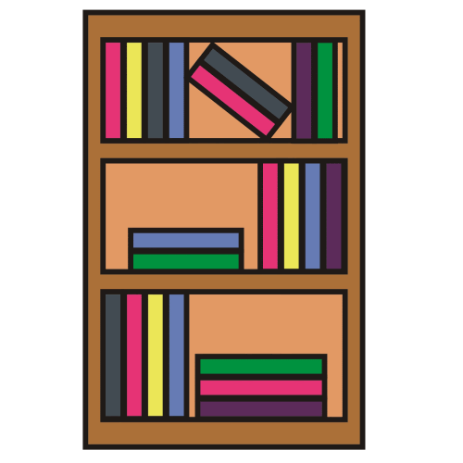 |  | Make a Book List  Make a list of your top 5 fave books  Make a list of your top 5 fave characters  Make a list of five books you want to buy  Make a list of the books you will read this week  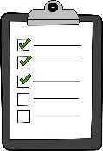 |  | Book Character Dress-Up  Have a fun time trying to recreate the cover of a book or dress up as a book character  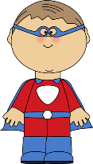 |  | Do a Genre survey:  Make a Tally sheet and ask members of your family or relatives which of these books they like best?  Mystery  Adventure  Science Fiction  Fantasy  Biography  Informational/Facts  Other  What were your results?
30 min Reading Ideas | 30 min Reading Ideas
Username: 3S Password: cat123  Daily selection of cool news ideas for kids  https://newsomatic.org/login/  Owl Magazine Read Aloud:  https://www.owlkids.com/audio/?utm_source=Owlkids.com&utm_medium=web&utm_campaign=Owlkids.com_Homepage&utm_content=Chirp%20Audio  National Geographic for Kids:  https://kids.nationalgeographic.com/ | Check out some magazines. What kind do you like to read?  Cooking  Fashion  Facts  Funny/Humor  Animals  Sports  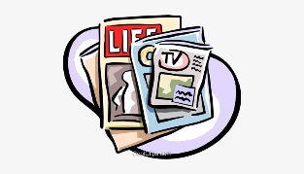 |  | Read to yourself. Choose any book you want. Cuddle up in a comfy spot, with a pillow or blanket.  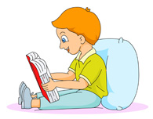 |  | Read aloud to someone. Choose a book you can read. Practice first on your own.  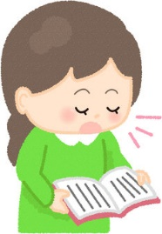 |  |  | Have someone tape you reading a book so you can hear how smooth it sounds. Use a book that you know and love. Does it sound like talking? Do you pause at commas and stop at end punctuation?  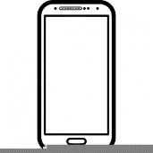
Other Subjects
Wellness:  Please see Miss Downey’s Teacher Page for weekly activities  http://nsee.nbed.nb.ca/teacher/miss-downey |  | Wellness: Ball practice Grab a ball, find a spot outside to use it:  Try dominant and non-dominant hands. Feet should be shoulder-width apart  Try one hand catches, V bounce/catch  Ball practice: Bounce and clap hands  Bounce and turn and catch  How far can you throw a ball???  Practice throwing a ball overhand, underhand, slow, fast
First Nation’s/Culture  Please see Ms. Mountain’s Teacher Page for weekly activities  http://nsee.nbed.nb.ca/teacher/ms-mountain |  | First Nation’s/Culture  Table Talk:  Who are your heroes? Why? What makes a hero?
Science Challenge:  http://stemnorth.nbed.nb.ca/sites/stemnorth.nbed.nb.ca/files/doc//y2020/May/asdn_weekly_steam_issue_7.pdf |  | Science:  Examine moss: Great time to see moss in the woods near your home. Go for a moss hunt with a parent and try and find three different types of moss.
Music:  Get dancing!  https://www.gonoodle.com/good-energy-at-home-kids-games-and-videos/ |  | Time to Dance:  Crank up your fave high energy song and play that air guitar! Move your body time!
Fun Friday Art Lesson: String Art  https://www.youtube.com/watch?v=aOCKr9MNn3M |  | Fun Friday Art Lesson: String Art  Have some thread or yarn, and small nails around the house? Nail an outline of the letter of your first name and make string art by looping around the nails.
French: Hello, Thank you, Goodbye  https://www.youtube.com/watch?v=bOdAzpZIS2U |  | Practice these words this week with your family:  Bonjour(Hello)  Merci (Thank you)  Au Revoir(Goodbye)

