Mrs. Sullivan’s Home Learning Choices Week Of May 11-15
Online or On Hand
Math | Math
Reflex Fact Practice  This is a webpage your child has used frequently in the past.  Link:  https://www.reflexmath.com/ | Elimination Materials: Two dice, paper for each player, pencil for each player  How to Play:  1. Each player writes numbers from 1 – 12 horizontally across the top of their paper  2. Players take turns rolling the dice  3. Add or subtract the two dice to get a sum/difference. Cross the answer off your paper.  Ex: Player 1 rolls a 2 and a 4, and crosses the number 6 off their paper.  4. The object is to be the first to cross all the numbers off their paper.
This Week’s Theme: Time  Sundials  https://youtu.be/1SN1BOpLZAs  https://education.abc.net.au/home#!/media/2971560/how-to-tell-time-using-a-sundial  https://www.edumedia-sciences.com/en/media/308-sundial  https://kids.britannica.com/students/assembly/view/228990 | This Week’s Theme: Time
 | Make a Sundial  Find a straight stick about as long as a ruler. Go outside on a sunny day at noon and sick it in the ground so it stands straight up. Put a small pebble where the shadow falls. Go out 1 hour later. Put another pebble where the shadow is. Continue for the next few hours. What do you notice?  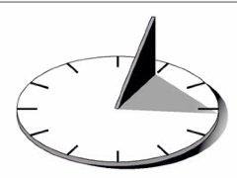 |  |  | Mark The Calendar  Draw or use a May calendar from your home.  Each day, write a note about something you did, saw, ate, special event in the spaces. Draw a heart on Mother’s Day on your calendar. When was it?  Draw a crown on Victoria Day.  When is it?  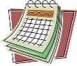 |  | Timer Practice:  How long does it take? Use a timer(cell phones and tablets have them) and time:  How long it takes you to:  brush your teeth?  eat breakfast?  tie your shoes?  Time other activities you do.  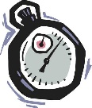 |  | Time:  Write these on a T chart:  What times do you:  Get up?  Eat supper?  Play outside?  Do home learning?  Do chores?  Go to bed?
Literacy: Theme: Board Games | Literacy: Theme: Board Games
Board Game Ideas  Make your own board game https://www.youtube.com/watch?v=r-7IvAnDCDE  Literacy Board Game Example  https://www.youtube.com/watch?v=wi8dC8n8hdg  Another Homemade Board Game  https://www.youtube.com/watch?v=yE_wzP9mKs8  Create a board game  https://www.pbs.org/parents/crafts-and-experiments/create-your-own-board-game | Examine Game Boards  Look around the house and find a board game or games.  Notice:  What materials does it use?  How is the game played?  How is the board laid out?  Play the game!  Good Luck!  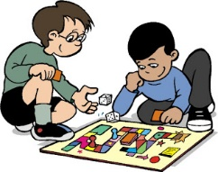 |  | Pick a Game Idea  Pick a theme for your game: Will you make a version of an old game:  Ex: Snakes and ladders?  Or will you make a totally new game? Ex: Space Aliens game, Mystery game, Ice Cream Factory game, Nascar Race game  Endangered Animals Game  How will the spaces look?  Ex: Circular game board, Rectangular, X shaped,  Card piles? Start? End?  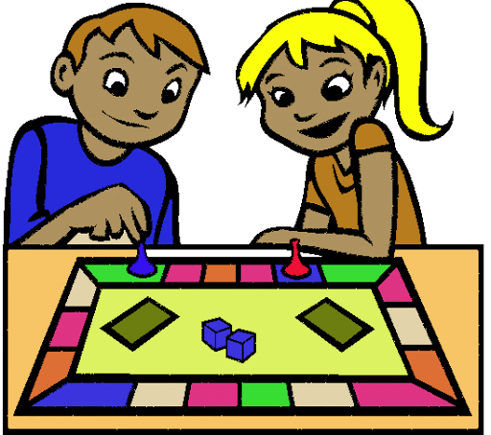 |  | Game Design  Think about these questions:  How do players win the game?  How many players?  Do you need dice?  Are there cards?  Are there markers, counters, spinners?  How does the game begin?  Do players have to roll the dice?  What can players do on their turns?  Plan your rules and write them on a piece of paper.  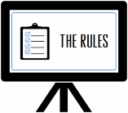 |  | Make your Game  Get materials you will need: Ex: Cardboard box, markers, pencil, ruler, scissors, glue.  Make/Draw your game and give it a catchy title.  Then invite a family member to play!  Have fun!  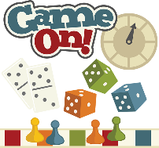
30 min Reading Ideas Word Work | 30 min Reading Ideas Word Work Activities
Pinata Party Spelling https://www.abcya.com/games/spelling_spree  Pancake Panic Homophones  https://www.abcya.com/games/pancake_panic_homophones  Homophones https://ca.ixl.com/ela/grade-3/homophones-with-pictures  Submarine Spelling https://www.abcya.com/games/dolch_sight_word_spelling  Scrabble https://www.turtlediary.com/game/word-scrabble.html | Homophones:  Many words sound the same but are spelled differently, and mean different things.  Ex: right/write  How many homophones can you make?  Start a list. 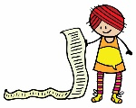 |  | Make and Break:  Choose three words to learn to spell from a book you’re reading today. Print each word neatly on paper and cut into small squares for Word Work.  - Make them.  - Break them.  - Make them again.  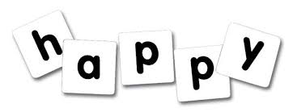 |  | Scrabble Scramble:  Make 2 sets of letter tiles to spell a longer word. (Print on paper and cut out) Ex: “information”  Set the timer for 2 minutes. Both people make words with their tiles. How many words can you spell with the letters?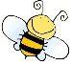 |  |  | Word Work:  Can you make 30 words using these?  e i d n n k s s  Must have 3 letters, be spelled correctly, and no proper nouns. Use all the letters. Can you get the final word?  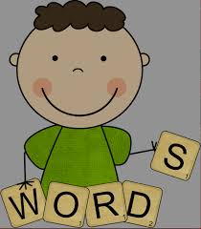
Other Subjects
Wellness:  Please see Miss Downey’s Teacher Page for weekly activities  http://nsee.nbed.nb.ca/teacher/miss-downey |  | Wellness:  Make some bubbles! Outside you go to blow them around! Try to catch them!  - 4 Tbsp water  - 1 Tbsp concentrated dish soap  - 2 Tbsp sugar  Put water in a bowl and pour in the dish soap. Add the sugar and stir gently until the sugar is dissolved. Make a homemade bubble blower by cutting the bottom from a plastic water bottle. Dip the cut end in the soap mix and use the lid end of the bottle to blow your bubbles.
First Nation’s/Culture  Please see Ms. Mountain’s Teacher Page for weekly activities  http://nsee.nbed.nb.ca/teacher/ms-mountain |  | First Nation’s/Culture  Table Talk:  What 4 animals would be important symbols for your family? What would they stand for?
Science Challenge:  http://stemnorth.nbed.nb.ca/sites/stemnorth.nbed.nb.ca/files/doc//y2020/May/asdn_weekly_steam_issue_7.pdf |  | Science: Soil Samples:  With your parent’s permission, get a shovel and go out to 4 different soil areas around your yard. Dig the shovel in, and turn up the soil and examine it. How are the soils different? Alike? What did you see that was interesting?
Music: Rain Stick  https://www.google.com/search?q=homemade+rain+stick-easy&rlz=1C1GCEV_en&oq=homemade+rain+stick-easy&aqs=chrome..69i57.7239j0j8&sourceid=chrome&ie=UTF-8#kpvalbx=_F4q4Xp3FFIzRtAaYkbXoDQ42 |  | Create a rain stick  Use a cardboard paper towel or wrapping paper cardboard tube. Tape one end closed. Scrunch tinfoil into a long thin strip that will fit inside the paper towel tube. Put a handful of uncooked rice inside the tube. Tape the end shut!
Fun Friday Art Lesson:  Toilet Paper roll Painting  https://www.youtube.com/watch?v=FpvIOpciq2Y |  | Fun Friday Art Lesson:  Use toilet paper rolls. Make many closely-spaced cuts going around the outside rim of the tube. Flatten to make the “dandelion” end and dip in paint, print onto background paper. Vary the depth of the cuts to change the print.
French:  Les Saisons(Seasons Song)  https://www.youtube.com/watch?v=PWhLSc_FpCM |  | Seasons drawing:  Divide a page into 4 equal parts and draw a season scene in each one. Label your scene: Le printemps(Spring) L’e‘te‘ (Summer), L’automne(Fall, L’hiver(Winter)

