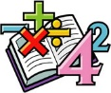
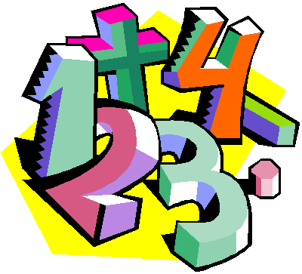
Suggestions for Home Learning Week 9 (June 1st to June 5th )
Grade 5 Math

 | Using No Technology | With Technology
Multiplication &  Division  Practice | Ideas to practice your Multiplication and Division Facts:  - Play Multiplication Snap with cards  - Use flash cards  - Make up 12 questions to solve  - Roll two dice and multiply the two numbers  Other link to practice at home:  https://www.weareteachers.com/22-fun-hands-on-ways-to-teach-multiplication/ | Study your math facts from 1 to 9.  You should be able to do 12 questions in one minute.  www.multiplication.com  https://www.abcya.com/search/?term=multiplication&type=game&id=0  https://www.abcya.com/games/number_ninja_multiples
Math  Review | The best review you can do is to master your multiplication and division facts from 0 to 9.  This will help you with all areas of math. | Some other sites to use to review all math concepts covered this year include:  www.dreambox.com/at-home  https://on.mathgames.com/grade5  https://www.iknowit.com/
Something New | Yay we made it to our last unit. It is all about Transformations of shapes. This is a fun unit.  In your duo-tang, look at pages 118 to the end of the booklet. You will find lessons on Translations, Reflections and Rotations. | Here are some videos to help you learn this new concept.  Translations:  Reflections:  Rotations:
A Bit  of  Fun | See “Camp Magician” math activity (Week 6) on the next page. | Do some explorations with symmetry (Reflection): Find a picture in a magazine and cut it vertically
- If you still want some more, check out this site: https://www.k5learning.com/free-math-worksheets/fifth-grade-5

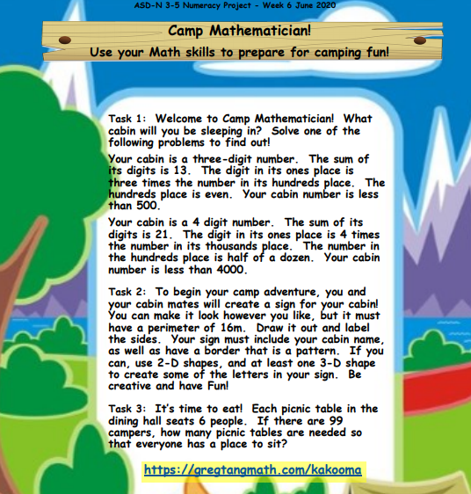
https://gregtangmath.com/kakooma

