Welcome to our 10th and last week of Home Learning. Summer has finally arrived! Choose some fun learning activities you can enjoy!
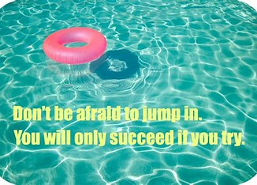
Remember, you can visit Mrs. Mutch’s teacher page for Math, Miss Downey’s for Wellness, Miss Mountain’s for First Nations Learning and Mrs. Estys’ has lots of learning activities too.
Find a comfy spot and read for 30 minutes!
While you are reading this week try making some inferences. To find out what an inference is, read the definition below. You can also watch the videos on YouTube on Making Inferences by McGraw Hill.

- What is an inference definition for kids? | AnswersDrive
https://answersdrive.com/what-is-an-inference-definition-for-kids-872273

An inference is an idea or conclusion that's drawn from evidence and reasoning. An inference is an educated guess. We learn about some things by experiencing them first-hand, but we gain other knowledge by inference — the process of inferring things based on what is already known. You can also make faulty inferences.
What is inferring in reading?
Inferring is a strategy used before, during and after reading. Predicting is a part of inferring. To infer, readers notice references in the text and mix the new information with personal background knowledge to draw correct conclusions.
Infer - LikeToRead
www.liketoread.com/infer.html

Learn about Inferencing: Introduction to Reading Skills: Making Inferences- McGraw-Hill PreK-12

Click on and watch the 2 videos below to learn about inferencing and find out how we use it to help us figure things out about what we see, hear and read:
https://www.youtube.com/watch?v=1oqdI5JMJnM
https://www.youtube.com/watch?v=acZzllpIYz4
Here is a funny video to watch and practice some inferencing:
Videos of Pigeon Impossible YouTube by Lucas Martell

MAKING INFERENCES

LET'S PRACTICE MAKING INFERENCES!
* CAN YOU INFER WHAT CITY THIS MOVIE TAKES PLACE IN?
* CAN YOU INFER WHAT THE MAN'S JOB IS?
* CAN YOU INFER HOW THE MAN FEELS ABOUT THE PIGEON?

WE MAKE INFERENCES WHEN WE:
* USE OBSERVATIONS WE MAKE WHEN READING
* USE OUR PRIOR KNOWLEDGE AND EXPERIENCES
* USE DETAILS FROM THE TEXT AS CLUES

Literacy & Social Studies Connection
1) Make a bucket list of places in New Brunswick you would like to visit and explore this summer. Find or look up a map of New Brunswick to discover some places you may never heard of before. A good website to find out more about NB is:
https://www.kidzone.ws/geography/newbrunswick/index.htm
2) Choose some of the places on a map of NB and do some research to find out more about them.

French Learning:
Here is a French vocabulary game to practice articles of clothing:
MIX AND MATCH game to learn - french-games.net
Can you practice how to say what you are wearing?
Ongoing Science and Cross-Curricular learning:
The following link has weekly learning activities that our District- Stem North-has developed for our students:
Check out some ideas on boatbuilding or the cool Science activity to find out about items that sink or float. Write about what you find out in your Science Journal.
http://stemnorth.nbed.nb.ca/sites/stemnorth.nbed.nb.ca/files/doc/y2020/May/asdn_weekly_steam_issue_10.pdf

If you have any questions or concerns I can be reached on our NSEE Grade 5 Facebook Page or by e-mail at luticha.taylor@nbed.nb.ca
It would be great to see each of you when you come to pick up your report cards in a couple weeks. I hope you all have a great summer and enjoy time with family and friends.
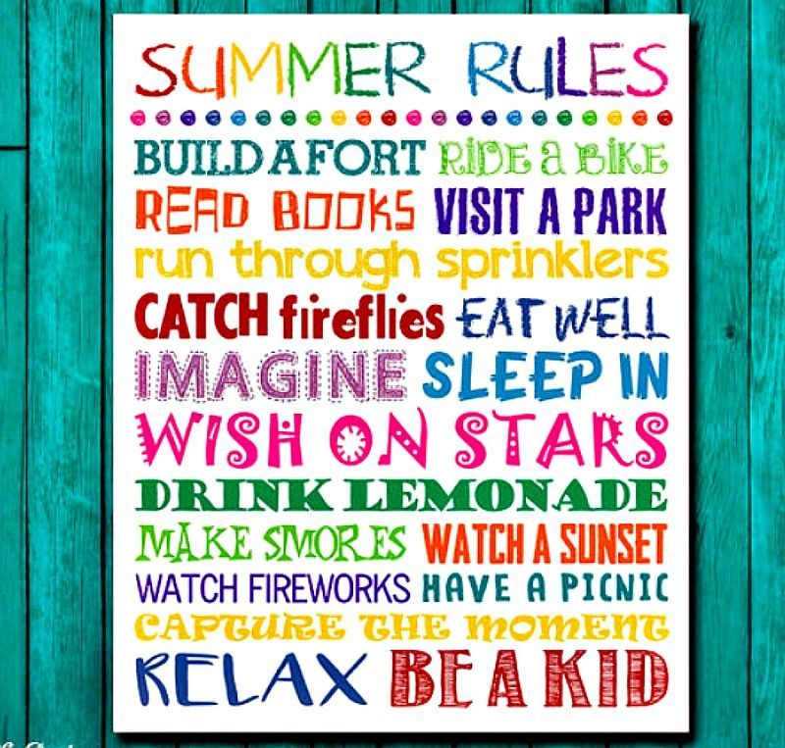
Have a wonderful week!
Mrs.Taylor

