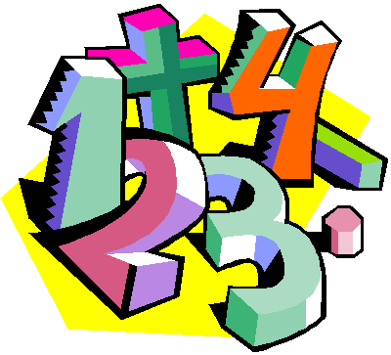
Suggestions for Home Learning Week 4 (April 27th to May 1st)
Grade 5 Math

 | Using No Technology | With Technology
Multiplication & Division  Practice | Use a deck of cards to play Multiplication Snap. You can play by yourself by picking two card and multiply them or you can play with a family member by each of you revealing a card to multiply.  Use flash cards that you can print or make yourself to practice facts.  Get someone to make up 12 questions for you to solve. | Study your math facts from 1 to 9. You should be able to do 12 questions in one minute.  www.multiplication.com  https://www.abcya.com/search/?term=multiplication&type=game&id=0  https://www.abcya.com/games/number_ninja_multiples
Math  Review | Measurement Review:  Dust off your ruler and find 10 items around your house to measure. List the length in mm, cm and m.  Multiplication Review:  Practice multiplying by 10, 100 and 1000  Practice dividing by 10, 100 and 1000 | A great website to use is Dreambox to review all math concepts that we have covered this year.  It will take you 5 minutes to sign up and your child will be able to work at their own pace for the rest of the school year to review and learn new concepts.  www.dreambox.com/at-home
Something New | Now that we know a little more about Fractions, we will move on to decimals. Fractions can be written as a decimal too.  35/100 = 0.35, 6/100 = 0.06, 4/25 =16/100 = 0.16  This week, practice changing fractions to decimal like above.  When you have that mastered, practice adding and subtracting decimals. 35.63 + 59.48 or 86.32 – 42.36  You can use a number cube to give you your numbers or ask someone to make some up for you on paper. | Now that we know a little more about Fractions, we will move on to decimals. This lesson with help you add and subtract decimals.  http://www.learnalberta.ca/content/me5l/html/Math5.html  Choose Lesson: Addition and Subtraction of Decimals
A Bit  of  Fun | See “Nature Ninja” math activity on next page.  or  Print out this sheet for some Fraction Fun on paper  https://www.coloringsquared.com/wp-content/uploads/2013/12/FFC4-Lioness-common-core-fraction-decimal-percent-worksheets.pdf | Here are some fun Fraction games to play:  https://www.splashlearn.com/fraction-games?adCampaign=9925160323&adGroup=103181786849&adID=432351970063&adTag=&gclid=EAIaIQobChMIj8D2rLGB6QIVghHTCh1x_AscEAEYASAAEgJeIPD_BwE&ipad_blocker_disabled=1  http://www.gamequarium.org/dir/Gamequarium/Math/Fractions/Equivalent/
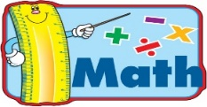
Extra practice sheets you can print if you really really want them!

Comparing Decimals Review: https://www.k5learning.com/worksheets/math/grade-3-compare-decimals-a.pdf
Adding Decimals: https://www.k5learning.com/worksheets/math/grade-3-adding-decimals-in-columns-1-digit-a.pdf
Subtracting Decimals: https://www.k5learning.com/worksheets/math/grade-3-subtracting-decimals-in-columns-1-digit-a.pdf

