Hello again Grade 5 Students & Parents/Guardians,
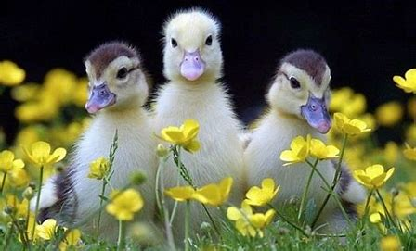
I hope you are all enjoying our Spring weather. It is hard to believe it is the last week of April. I hope you are finding some activities to enjoy!
Each week you can visit Mrs. Mutch’s teacher page for Math, Miss Downey’s for Wellness, Miss Mountain’s for First Nations Learning and Mrs. Estys’ has lots of learning activities too.

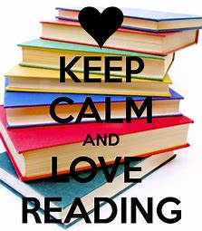Our Reading Goal is 30 minutes a day!
This week try to find some non-fiction texts to read. You can read a book about nature, an internet article, a magazine, or any other non-fiction text that you are interested in. Below are links to sites with free non-fiction texts:
https://classroommagazines.scholastic.com/support/learnathome.html
http://scholastic.ca/kids/thingstodo/
https://www.getepic.com/
https://www.literacyfootprints.com/digital-reader

After you have finished your reading, choose two of the boxes below to answer.
What questions do you have about the topic? | What connections did you make as you read?  Text to Self?  Text to World?  Text to something else you have read? | Write about some facts you learned from your reading. Share your opinion about something you read.
Pick three events from your book or article and write about the things that caused those events to happen. | Describe the main ideas and details you read about this week. | Compare or contrast ideas from the book. Write about two things that are similar or different.
Draw a picture that summarizes what you learned this week. Label your drawing to identify  important ideas. | What information was most interesting to you? | Write a letter to the author. What did you like?  What questions do you still have?

Literacy & Science:
An interesting way to do some writing is keeping a journal. You can keep a weekly journal to write and draw about anything that interests you. Click on the link below to find out more about keeping a Science Journal this Spring.
Keeping a Science Journal:
https://www.youtube.com/watch?v=E6iB5B3Lz9I
Ideas for Journal Writing
Respond in your journal using this prompt.  Actor Robin Williams said, “Spring is nature’s way of saying,” Let’s party!” What do you think he meant? | Take a walk outside and look around for a bit!  List 10 phrases about what you notice. Be descriptive in your journal and have fun.  Example: Birds chirping, bugs crawling, etc. | Make a list of community spring jobs you can do in your community. Use your journal to keep track of the jobs. We can all make a difference!
Take notes on your surroundings in nature to guide you in doing this activity. Write words you see, hear, smell or think. | Go for a walk and sketch what you see! Paint a picture with words. | In your journal create an acrostic poem, using letters in a word or topic to begin each line. All words and phrase must connect to topic. You can use SPRING.
Write a story to your family about what you like about Spring? Use your journal and share! | Pretend that you can go anywhere in the world for Spring break. Where would you go and what would you do there? | Make a collage of Spring. Find pictures that represent what spring looks like for you and your family in 2020.
The following link has some fun weekly learning activities and challenges that our District- Stem North- has developed for our students to access and enjoy:
http://stemnorth.nbed.nb.ca/sites/stemnorth.nbed.nb.ca/files/doc//y2020/Apr/asdn_weekly_steam_issue_4.pdf

French Learning Site:
I am adding a site we often use in our French class. The students know many of the songs and they can watch the video to practice French at home:
https://www.youtube.com/playlist?list=PL358891FD40D3E290
Song #21 on the list is the song “Le printemps” by Matt Maxwell. It is all about “Spring” and the different things we see and do this time of year. Are there some new words you can learn?
Sylvia Duckworth is a French Second Language Teacher in Toronto and she has many online learning activities for students.

If you have any questions I can be reached by e-mail at luticha.taylor@nbed.nb.ca

If you would like to share pictures of some artwork or projects you are working on you could put them on our NSEE Grade 5 Facebook Page. Thank you to Riley & Josephine for putting some pictures on of some cool projects they completed!

Hang in there and have some fun learning!
Mrs. Taylor

