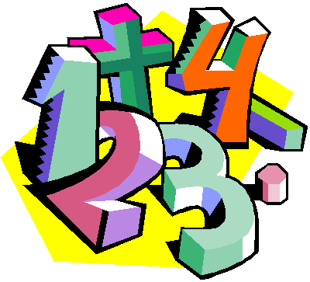
Suggestions for Home Learning Week 3 (April 20th to 27th)

Grade 5 Math

 | With No Technology | With Technology
Multiplication & Division  Practice | Use a deck of cards to play Multiplication Snap. You can play by yourself by picking two card and multiply them or you can play with a family member by each of you revealing a card to multiply.  Use flash cards that you can print or make yourself to practice facts.  Get someone to make up 12 questions for you to solve. | Study your math facts from 1 to 9. You should be able to do 12 questions in one minute.  www.multiplication.com  https://www.abcya.com/search/?term=multiplication&type=game&id=0
Math  Review | Money Review: This is a great time to talk about money. Students can create a budget for a grocery order. They can help plan your meals for the week, create a shopping list and add up the total of your items.  Addition & Subtraction Review: Play some card games with your family. War, Crazy 8’s, Go Fish, Uno, etc. | A great website to use is Dreambox. This is free for parents to sign up their kids for 90 days. This site reviews all math concepts that we have covered this year. It will take you 5 minutes to sign up and your child will be able to work at their own pace for the rest of the school year to review and learn new concepts.  www.dreambox.com/at-home
Something New | 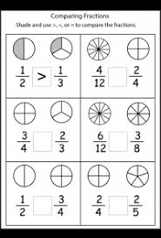  Please read the “With Technology” column first.  Last week you practiced how to draw and shade in pictures of fractions.  This week you can practice comparing fractions by drawing/shading them and then adding a < (less than), > (greater than) or = (equals) between the two fractions.  Hint 1: The arrow always points to the smallest number  Hint 2: Please shade your two fractions so that they are easy to compare. Shade the same side of the shape. | This week, continue to explore the wonderful world of fractions. Fractions can be compared to each other to see which one is greater than or less than. If a fraction has the same denominator (the bottom number in a fraction) it is easy to solve. But it the denominators are different, you will have to find an equivalent fraction. Use pictures to help. Check out this video to help you understand.  http://www.learnalberta.ca/content/me5l/html/Math5.html  Choose Lesson: Comparing and Ordering Fractions
A Bit  of  Fun | 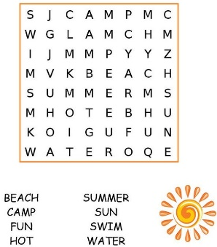  - Last week you created your own crossword puzzle. This week, can you design your own Word Search puzzle for someone to solve.  1. Make a list of words  - 2. Arrange the words in a grid pattern either horizontally or vertically  - 3. Remember to line your letters up carefully so that they are straight | In Tech Class we learned how to type properly (use all of your fingers) on the keyboard and see what our WPM (words per minutes). Are you faster now?  See if you can race your parents/siblings score.  https://www.roomrecess.com/mobile/WPM/play.html  Do you need to practice your keyboarding some more?  https://www.abcya.com/search/?term=keyboarding&type=all  https://www.bbc.co.uk/bitesize/topics/zf2f9j6/articles/z3c6tfr
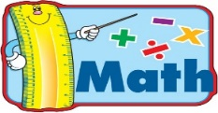
Extra practice sheets you can print if you really really want them!
Addition Review: https://www.k5learning.com/free-math-worksheets/fourth-grade-4/addition/add-4-digit-numbers-in-columns
Subtraction Review: https://www.k5learning.com/free-math-worksheets/fourth-grade-4/subtraction/subtract-4-digit-numbers-with-regrouping
Money Review: https://www.k5learning.com/free-math-worksheets/third-grade-3/counting-money/counting-money-canadian-shopping-problems
Comparing Fractions: https://www.k5learning.com/free-math-worksheets/fourth-grade-4/fractions/comparing-proper-fractions

