Hello Grade 5 Students & Parents/Guardians, 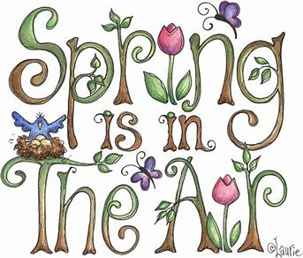
I hope you are all keeping well. This is week 3 of our Home Learning experience. Keep trying your best and have fun with it.
Remember you can visit Mrs. Mutch’s teacher page for Math, Miss Downey’s for Wellness Activities and Miss Mountain’s for First Nations Learning.
Keep reading! Our Reading Goal is 30 minutes a day.
Many students I spoke with were interested in the Titanic so I found some more Literacy Activities to help you learn more about this infamous ship. Go ahead and choose what you would like to do to keep learning!
Creative Writing Ideas:
- Imagine you were one of the passengers on the Titanic. You only have one small suitcase to pack all of your possessions to start a new life on the other side of the world. What things would you pack in your suitcase?

- You are on board the Titanic and you realize it is sinking. People are scurrying around everywhere and there are no lifeboats left. As you take the plunge into the icy waters what are you thinking? Do you have a plan to try to survive?

- Imagine you are one of the survivors of the Titanic. A reporter has come to ask you questions. Write down what your answers would be to the following questions:
- Who are you? Who were you travelling with?
- Where were you going? Why?
- Can you describe the ship? Or draw a picture of it?
- What happened to the ship?
- How did you react when you knew the ship was sinking? What were other people doing all around you?
- What happened in the end? How did you survive?
- How do you feel now? Why?

Word Work Activity:
How many words can you make using the letters in the word Titanic?
Set a 10 minute timer. You can even ask someone to take on this challenge with you. Read and compare your list of words to each other. Did you find any of the same words? What different words did you find?

Online Learning Sites:
National Geographic Kids has 20 Top Titanic Facts. What did you already know about this infamous ship?
https://www.natgeokids.com/nz/discover/history/general-history/would-you-have-survived-the-titanic/

Titanic Art Ideas/Projects:
https://www.pinterest.co.uk/pin/387028161709312638/
If you have any questions I can be reached by e-mail at luticha.taylor@nbed.nb.ca

If you would like to share pictures of your artwork or projects for classmates to see you could put them on our NSEE Grade 5 Facebook Page.
Happy Learning! Have a great week!
Mrs. Taylor

