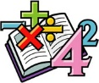
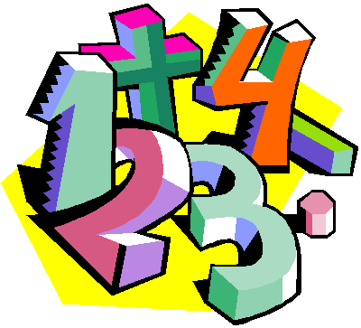
Suggestions for Home Learning Week 1 (April 6th to 9th)

Grade 5 Math

 | With No Technology | With Technology
Multiplication & Division  Practice | Use a deck of cards to play Multiplication Snap. You can play by yourself by picking two card and multiply them or you can play with a family member by each of you revealing a card to multiply.  Use flash cards that you can print or buy at the Dollar Store to practice facts.  Get someone to make up 12 questions for you to solve. | Study your math facts from 1 to 9. You should be able to do 12 questions in one minute.  www.multiplication.com  https://www.abcya.com/search/?term=multiplication&type=game&id=0
Math  Review | Capacity Review: Check out your fridge and make a list of 10 items. What is the capacity of each item in mL or L? Can you put them in order from least to greatest?  Geometry Review: Go on a Scavenger Hunt around your house. What objects to you see? Make a list of 10 items and list what 3D shape it matches. (Rectangular prism, cube, triangular pyramid, etc.) | A great website to use is Dreambox. This is free for parents to sign up their kids for 90 days. This site reviews all math concepts that we have covered this year. It will take you 5 minutes to sign up and your child will be able to work at their own pace for the rest of the school year to review and learn new concepts.  www.dreambox.com/at-home
Something New | 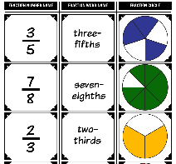  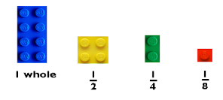  Using Lego is a great way to learn about fractions. The numerator is the top number (that tells you what is counted) and the bottom number is the denominator (that tells you how many equal parts the whole is divided into). Use Lego to model some fractions.  Draw some shapes. Divide your shapes into equal parts, shade some parts in and name them. | The next unit we were going to start was Fractions. Here is a video to get you started. Do not listen to what anyone says…fractions are fun!  http://www.learnalberta.ca/content/me5l/html/Math5.html  Choose Lesson: Proper Fractions
A Bit of  Math Fun | 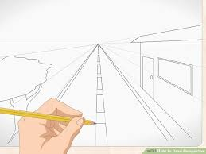  Can you draw a Perspective Drawing (similar to what we started in class)?  Remember to start out with a horizontal line in the middle or your page with a vanishing point.  All you need is a ruler, a pencil and pencil crayons. Have fun creating! | We started these awesome Perspective Drawings but didn’t get to finish them. Here is the one we started and another one to try. All you need is a ruler, a pencil and pencil crayons. Have fun creating!  We would love to see them after you are done. Take a picture and post it on our Grade 5 Facebook page.  https://www.youtube.com/watch?v=sZD8BjTK8dE  https://www.youtube.com/watch?v=a8QWyIrJFkg
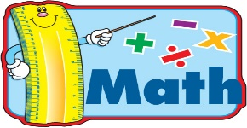
Extra practice sheets you can print if you really really want them!

Shapes Review: https://www.k5learning.com/worksheets/math/grade-5-geometry-classifying-quadrilaterals-a.pdf
Capacity Review: https://www.k5learning.com/worksheets/math/grade-4-measurement-units-of-capacity-metric-a.pdf
Geometry Review: https://www.k5learning.com/worksheets/math/grade-4-geometry-classifying-quadrilaterals-a.pdf
Fractions Introduction: https://www.k5learning.com/worksheets/math/grade-3-identify-fractions-color-a.pdf

