Razz Kids Login:

Log in to https://www.raz-kids.com/
Click the green login button on the right

Enter your Teacher’s Username: Sully3

Click on your name from the list:

Click on your password: It’s a picture! 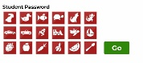

Once you get in, look at the top Left, where it says Kids A-Z Reading.
Click on the word Reading, then choose Level Up
The books you see are ones I’ve chosen for you to read. Each time you finish a book and answer questions, you earn $ to spend. Good Luck!

