Mrs. Sullivan’s Home Learning Choices Week Of April 6-10
Online or On Hand
Math | Math
Reflex Fact Practice  This is a webpage your child has used frequently in the past.  Link:  https://www.reflexmath.com/  Students should know how to log in, but email me if they can’t remember their passwords and I will send it to you. | Play a game:  Tens Go Fish: Play Go Fish by making card number pairs that add to ten. Ask for the number you need to add to a card in your deck make a total of ten. Use joker as wild card.  Tens Concentration: Remove Jack, Queen, King, Deal cards in three rows, face down. Turn over 2 cards at a time. Try to make pairs whose sum is ten.  Turnover (War): Each person turns over a card, first to correctly call out the sum of two cards =1 point. First to 5 points wins  Tens Dice Game: Each person takes turns rolling two dice. Each roll where the dice add to make ten=1 point. First to 5 points wins
This Week’s Theme: Measurement –Use centimeters for all games  https://www.splashlearn.com/math-skills/second-grade/measurements/measure-length-metric-units  https://www.funbrain.com/games/measure-it  https://www.abcya.com/games/measuring  https://www.topmarks.co.uk/r.aspx?sid=5368 | This Week’s Theme: Measurement
 | Measure a long jump:  Mark a spot as a starting line and with two feet on the floor, take the longest jump you can.  How far can you go?  Jazz it up:  Estimate the distance first, and then measure it  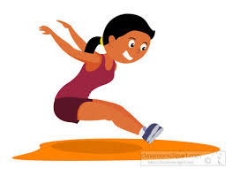 |  | Measure a snowbank:  Use a shovel, stick, or your own body and measure the height of the tallest snowbank in your yard.  Check it again in a few days. What happened? | Measure the people in your family:  Do one at a time, against a wall.  Use your hand, a piece of tape, Post-it, or sticker to mark their height.  How tall is everyone?  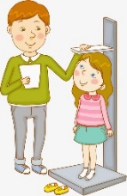 | Draw line lengths:  Use paper, pencil, ruler/measuring tape. If none, use your pinky to estimate.  Try to draw an estimated line that is exactly 2 cm, 5 cm, 17 cm.  Measure to see how long it actually is.  How close were you?  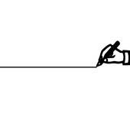
Literacy: This week’s theme: Caring | Literacy: This week’s theme: Caring
http://aminahsworld.org/ Make a caring sign using this art site  https://www.abcya.com/games/abcya_paint Paint a caring sign here. Let your imagination GO!  https://www.abcya.com/games/friendly_letter_maker We’ve used this one in class before.  https://pbskids.org/daniel/games/make-a-card Enjoy card making!  https://www.toonytool.com/ Make a cartoon to make someone laugh  http://www.readwritethink.org/files/resources/interactives/comic/ Make a funny comic  https://www.storyboardthat.com/storyboard-creator Make a storyboard-how silly can it get? | Make a sign for your kitchen or living room window. Think of a positive message you can write on it. Tape it up.  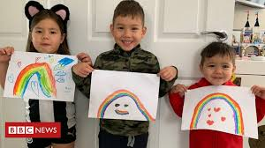  Picture from BBC.com |  | Make a card or letter to someone you love in your home.  Read/give it to them at supper tonight.  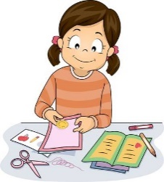 | Draw a cartoon or comic where something funny happens. Share it with someone and see if they laugh.  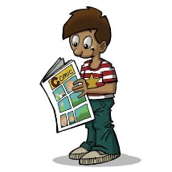 | Make a poster showing your fave:  - Supper  - Sport  - Toy  - Animal  - Dessert  Post it on the fridge.  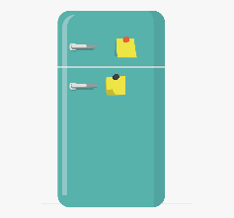
30 min Reading Ideas | 30 min Reading Ideas
Tumblebooks-Your choice  https://swv44svru02.gnb.ca/login?url=http://www.tumblebooklibrary.com/auto_login.aspx?U=nblib&P=libra Our class library card number is: 013288785 (Copy and paste)  https://www.storylineonline.net/ Your choice  http://www.professorgarfield.org/toon_book_reader/index.html Your choice  https://www.starfall.com/h/ir-3plays/?sn=im-reading Your choice  http://www.nourishinteractive.com/kids/healthy-games/11-kids-fun-cooking-chef-game | Look at a family photo album or your baby pictures.  How have you changed?  Which picture do you like the best?  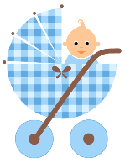 |  | Read to yourself. Choose any book you want. Cuddle up in a comfy spot, with a pillow or blanket.  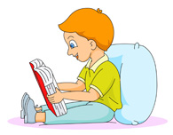 | Read aloud to someone. Choose a book you can read. Practice first on your own.  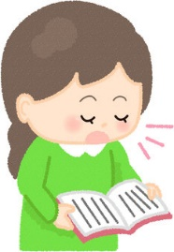 | Read a Recipe:  Go through any cookbooks your family may have. Find the one that looks the most delicious.  What was it?  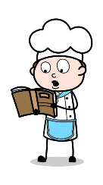
Other Subjects
Wellness:  Please see Miss Downey’s Teacher Page for weekly activities  http://nsee.nbed.nb.ca/teacher/miss-downey |  | Wellness:  Make a ditch: It’s that time of year when water is running everywhere. Go outside and grab a stick or shovel, and make a ditch to let the water flow away from the driveway or a large puddle in your yard.
First Nation’s/Culture  Please see Ms. Mountain’s Teacher Page for weekly activities  http://nsee.nbed.nb.ca/teacher/ms-mountain |  | First Nation’s/Culture  All My Relations:  Draw a family tree that goes to your great grandparents
Science: Challenge#1 Grades 3-5 Bird Feeder  http://stemnorth.nbed.nb.ca/sites/stemnorth.nbed.nb.ca/files/doc//y2020/Mar/asdn_weekly_steam_issue_1.pdf |  | Science:  Nature Hunt:  Can you spot: a bird, an animal track, a tree bud, moss, lichen?
Music: Try these virtual Boomwhackers. Play You tube Popcorn  https://www.musick8kids.com/html/play_bw.php |  | Music:  Can you make your own boomwhackers from different length toilet paper rolls, plastic bottles, wrapping paper rolls, or sticks? Show us your talent!
Fun Friday Art Lesson:  Draw Spring Stuff-You Choose  https://www.youtube.com/playlist?list=PLnoO3k54vcBRiV8USys5g9UMwyUf5KJWV |  | Fun Friday Art Lesson:  Go outside and find interesting objects- a tree branch, rock, leaf.  Draw and try to use shading, or  Arrange in a way that is pleasing to you to look at from one of your windows

