Mrs. Sullivan’s Home Learning Choices Week Of April 27-May 1
Online or On Hand
Math | Math
Reflex Fact Practice  This is a webpage your child has used frequently in the past.  Link:  https://www.reflexmath.com/ | Play 25 The object of the game is to get cards that add to exactly 25, by adding the total of any cards in your hand. Remove face cards first. Dealer deals out 3 cards to each player. Players draw 1 card from deck each turn. Each time you can make a total of 25 with your cards, you get a point, and lay only those cards down in a pile in front of you. If you have no cards left in your hand when you make your 25, you draw 3 new cards. Play until draw deck is used. Whoever made the most “25” piles wins!
This Week’s Theme: Perimeter  https://toytheater.com/perimeter-climber/ Add sides  https://apps.mathlearningcenter.org/geoboard/ Geoboard Perimeter  https://www.mathsisfun.com/geometry/perimeter.html Measure perimeters  http://www.learnalberta.ca/content/me3us/flash/lessonLauncher.html?lesson=lessons/12/m3_12_00_x.swf Perimbots  http://www.shodor.org/interactivate/activities/PerimeterExplorer/ Perimeter explorer | This Week’s Theme: Perimeter
 | Perimeter hunt  Gather these things:  Book  Kleenex box  Photo  Playing card  Measure the distance around the rim of the 4 sides in centimeters.  What were their perimeters? |  |  |  | Shoe Too  How would you find the perimeter of the sole of your shoe?  Give it a try.  How did you do it?  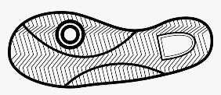 |  | Card Perimeters  Use 4 playing cards.  Arrange them flat on a table any way, but with sides touching together, no overlaps.  Try making 3 different shapes.  Then measure their perimeters each time. What did you notice? |  | Quadriperimeter  Roll dice 4 times.  Each roll will be the length of one side of your shape in centimeters.  Can you make a closed quadrilateral (4 sided shape)?  What is the perimeter of it?  1 point for whoever has the largest perimeter.
Literacy: Theme: Travel Back in Time | Literacy: Theme: Travel Back In Time
http://www.virtualmuseum.ca/sgc-cms/expositions-exhibitions/esprits-spirits/English/Dig/digdown.html Go Dig!  https://www.brainpop.com/games/jowilderandthecapitolcase/?topic_id= Solve Artifact Hunt  https://www.amnh.org/explore/ology/archaeology/tools-of-the-trade2 Archaeologist Tools  https://www.youtube.com/watch?v=ewqFhNw9k7g Marbles  https://www.youtube.com/watch?v=VpHTPnrYLzQ Cats cradle video  https://www.wonderopolis.org/wonder/what-makes-a-toy-top-spin Toy Top  http://www.waynesthisandthat.com/how%20to%20make%20button%20spinners.html Button Spinner  http://www.mugwumps.com/whammy.html | 1.Call a grandparent or elderly relative:  Ask them:  When you were in Grade3:  What was school like?  What device did you use to listen to music?  What were popular songs?  What toys did you play with?  What games did you play?  2.Do a handprint or hand tracing  Print or write your full name neatly on it.  Write date and place.  Write the answers to the same questions you asked your relative.  Put in your own memory book or photo/scrapbook album. |  |  | Play an old time game:  Cats Cradle  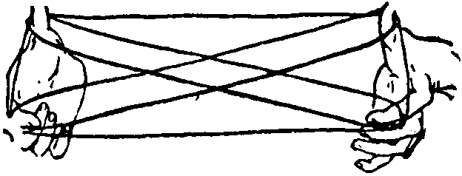  Marbles  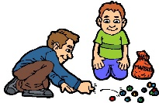  Top  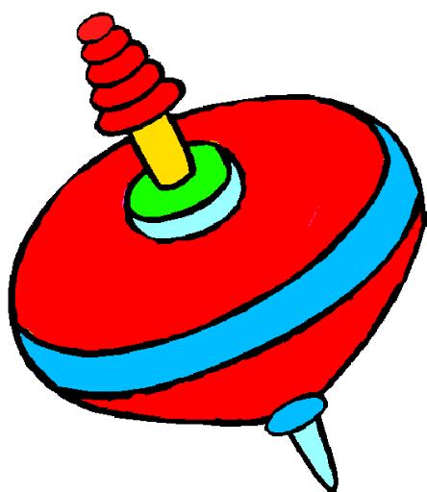 |  | Make a Button Spinner or a Pencil Spinner(Whammy Diddle)  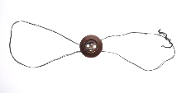  Start with the largest button you can find.  Thread about a metre of string through each side to form a loop. Tie it off.  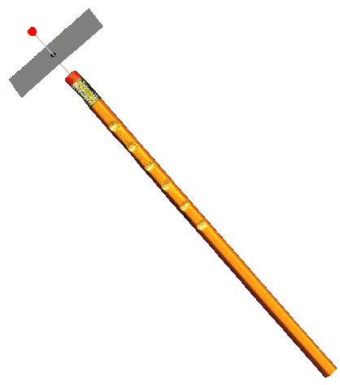  Get a parent to make notches on an old pencil. Make a spinning wing out of cardboard. Pin it into the eraser using a thumbtack. Use another pencil to run along the notches. |  | Kitchen table museum: Make a museum display of 5 old objects from your home: toys, tools, clothes, jewelry  dishes/china,  photos, record albums, cooking utensils, books  quilts, buttons, other collections  Make a label to lay beside each item for your family to read. It should have the name of the object, the age, and what it is made of /used for.  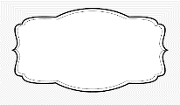
30 min Reading Ideas | 30 min Reading Ideas
http://www.readwritethink.org/files/resources/interactives/construct/ Construct a word  https://pbskids.org/superwhy/games/wonder-reds-rhyme-racer/index.html Rhyme  http://www.handwritingforkids.com/handwrite/cursive/animation/lowercase.htm Handwriting  https://www.abcya.com/games/make_a_word_searchWord Search  https://www.abcya.com/games/letter_blocks Letter Blocks  http://learnenglishkids.britishcouncil.org/games/wordshake Wordshake game |  | Rhyming game  How many rhyming words can you make that end with these word families?  -at  -in  -op  -ate  -ine  -ope |  | Cursive writing  Practice writing your name  Practice writing  your correct address |  | Do a Crossword puzzle or Word Search  Or  Make a word search  Choose 10 words  Draw a 15 X15 grid  Print each word neatly in different parts of the grid. You can go in any direction.  Fill in the empty parts with random letters. |  |  | Word Work: Can you make 30 words using these?  a e e i c n p t  Must have 3 letters, be spelled correctly, and no proper nouns. Use all the letters. Can you get the final word?
Other Subjects
Wellness:  Please see Miss Downey’s Teacher Page for weekly activities  http://nsee.nbed.nb.ca/teacher/miss-downey |  |  | Wellness: Sock Bowling  Make three sock balls.  Clear a floor space in your house, like a hallway.  Set up six empty empty plastic bottles as bowling “pins” at one end of the space.  Roll the sock balls on the floor and try to knock over the pins! Strike!
First Nation’s/Culture  Please see Ms. Mountain’s Teacher Page for weekly activities  http://nsee.nbed.nb.ca/teacher/ms-mountain |  |  | First Nation’s/Culture  Table Talk:  What is one thing you can’t do yet that you want to practice?  Ex: whistle, cartwheel, backflip, hula hoop, ride bike, dribble basketball  What is your secret hidden talent that people at school might not know?
Science: Challenge  http://stemnorth.nbed.nb.ca/sites/stemnorth.nbed.nb.ca/files/doc//y2020/Apr/asdn_weekly_steam_issue_4.pdf  https://www.brainpop.com/games/birdsonghero/?topic_id= Learn to identify bird songs |  |  | Science:  Bird Watching:  Go out and spot birds or bird nests in your area. (This is a great time to spot nests before the leaves come in and hide them.) Use binoculars if you have them. How many different kinds can you find?
Music: https://www.cartoonito.co.uk/campaigns/xylophone-app |  |  | Music: Musical bottles-fill with water and experiment  Gather some unused different sized glass jars/bottles and fill them with different amounts of water. Use a wooden spoon and see what kinds of sounds you can make. How does changing the water level affect it?
Fun Friday Art Lesson:  Lunch doodles with Mo Williams: https://www.youtube.com/watch?v=RmzjCPQv3y8 |  |  | Fun Friday Art Lesson: Doodles  Make doodles using different kinds of lines like:  Triangles, spirals, straight lines, checkerboards,
French  https://www.french-games.net/frenchtopics |  |  | Make a poster  With these words at the top: J’aime (I like)  Draw some things that you like to do, eat, listen to, watch, play

