Mrs. Sullivan’s Home Learning Choices Week Of April 14-17
Online or On Hand
Math | Math
Reflex Fact Practice  This is a webpage your child has used frequently in the past.  Link:  https://www.reflexmath.com/  Students should know how to log in, but email me if they can’t remember their passwords and I will send it to you. | Play a game:  Tens Go Fish: Play Go Fish by making card number pairs that add to ten. Ask for the number you need to add to a card in your deck make a total of ten. Use joker as wild card.  Tens Concentration: Remove Jack, Queen, King, Deal cards in three rows, face down. Turn over 2 cards at a time. Try to make pairs whose sum is ten.  Turnover (War): Each person turns over a card, first to correctly call out the sum of two cards =1 point. First to 5 points wins  Tens Dice Game: Each person takes turns rolling two dice. Each roll where the dice add to make ten=1 point. First to 5 points wins
This Week’s Theme: 3D Shapes  https://www.turtlediary.com/game/edges-and-faces.html  https://www.education.com/game/2d-3d-shapes/  https://www.starfall.com/h/geometry/enviro-shapes/?t=291721973  https://mathsframe.co.uk/en/resources/resource/115/sorting_3d_shapes_on_a_venn_diagram#  https://www.turtlediary.com/game/3d-shapes.html  http://www.sheppardsoftware.com/mathgames/earlymath/shapes_shoot.htm  https://www.topmarks.co.uk/Flash.aspx?a=activity20  https://www.easypeasyandfun.com/toilet-paper-roll-dogs/ | This Week’s Theme: 3D Shapes
 | Shape search:  Go on a hunt for objects in your house: how many cubes, rectangular prisms, cylinders, cones,  pyramids, spheres can you find.  Take a picture and email it to me!  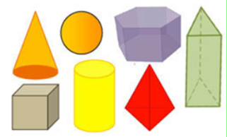 |  | Shape Sort:  Use the items you found in your Shape search on the kitchen or coffee table.  Sort the shapes this way:  6 faces/ Less than 6 faces  1 vertex/More than 1 vertex  More than 6 edges/Less than 6 edges  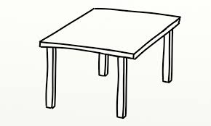 | Shape Guess:  Use the items you found in your Shape search.  Find a non-see through bag. Place an object in the bag from your shape hunt.  Give a clue about the object’s faces, edges or vertices. Ex: It has 6 faces.  Can anyone guess it? | Shape animal:  Can you make an animal using a cylinder? Use an empty cardboard toilet paper or paper towel roll.  Then use paper and pencils, markers, glue/tape to add legs, etc.  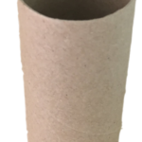
Literacy:This week’s theme: Entertaining | Literacy: This week’s theme: Entertaining
https://www.youtube.com/watch?v=CXAhfpF1aUE  Make stick puppets  https://www.youtube.com/watch?v=646Akz7CNjg Make a stage  http://www.crayola.ca/crafts/stick-puppet-theatre-craft/  Read about making a stage  https://www.thewiseowlfactory.com/free-3-billy-goats-play.pdf  https://www.thewiseowlfactory.com/Little-Red-Hen-readers-theater-play.pdf | Choose a favourite fairy tale story.  Ex:  Three Little Pigs  Red Riding Hood  Make stick puppets:  Draw/color each character you need for the story. Cut out. Tape to a pencil, popsicle stick, straw, or twig.  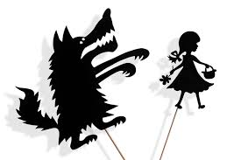  https://www.theaterseatstore.com/blog/creating-puppet-theater |  | Set up your stage and practice  Use the back of a couch, or behind an empty box. Decorate the box if you’d like.  Practice saying the parts with great expression and loudness to tell the story  Write the parts out if you’d like.(Like we did for our Dragon’s Den) | Make a poster advertising your home performance tomorrow.  Tell the place and time.  Draw and color a scene on the poster.  Post it on the fridge.  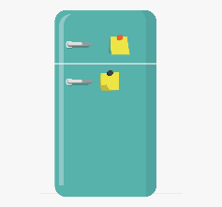 | Perform!  Present your play!  Don’t forget to introduce your characters.  Have a place where the audience will sit.  Take a bow at the end.
30 min Reading Ideas | 30 min Reading Ideas
Tumblebooks-Your choice  https://swv44svru02.gnb.ca/login?url=http://www.tumblebooklibrary.com/auto_login.aspx?U=nblib&P=libra Our class library card number is: 013288785 (Copy and paste)  https://www.storylineonline.net/ Your choice  http://www.professorgarfield.org/toon_book_reader/index.html Your choice  https://www.starfall.com/h/ir-3plays/?sn=im-reading Your choice | Read the grocery flyers.  Look through this week’s flyers. Take a pen and circle your favourite things. How much do they cost? |  | Read to yourself. Choose any book you want. Cuddle up in a comfy spot, with a pillow or blanket.  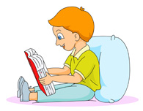 | Read aloud to someone. Choose a book you can read. Practice first on your own.  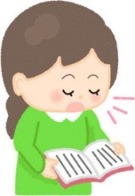 | Word Work:  Can you make 30 words using these?  a e e o c l n r t  Must have 3 letters, be spelled correctly, and no proper nouns.Use all the letters. Can you get the final word?  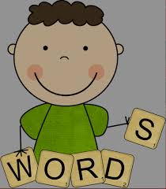
Other Subjects
Wellness:  Please see Miss Downey’s Teacher Page for weekly activities  http://nsee.nbed.nb.ca/teacher/miss-downey |  | Wellness:  Obstacle course:  Make a homemade circuit training course with 5 elements, in or outside. Have your family try it. Ex: Jump and touch door frame top 5 times, walk up and down stairs twice, do 20 wall push ups against the front door, etc.
First Nation’s/Culture  Please see Ms. Mountain’s Teacher Page for weekly activities  http://nsee.nbed.nb.ca/teacher/ms-mountain |  | First Nation’s/Culture  Table Talk:  At supper tonight, everyone answers this:  If I could travel to any place in the world, I would like to visit…  If I could do any job in the world I would…  If I could have any talent, I would…
Science: Watch: Cane’s Arcade  https://www.youtube.com/watch?v=faIFNkdq96U  Can you make your own? |  | Science:  Make a pinball arcade game out of cardboard boxes, paper and recycled items. Does it work?
Music: Junkyard Music Maker  https://pbskids.org/peg/games/music-maker |  | Music: Tissue Dance  - Each person places a tissue on their head.  - Play a fave song. When the music starts, everyone starts dancing.  - If your tissue falls on the ground, you are out unless you can catch it before it touches the floor, and put it back on your head and continue  - Last person standing wins
Fun Friday Art Lesson:  Make a suncatcher out of old crayons. Send me a pic!  http://www.crayola.ca/crafts/raindrop-sun-catcher-craft/ |  | Fun Friday Art Lesson:  Draw a picture of what you see when you look outside a window in your house. Choose one that has a special scene. Remember foreground, midground, and background.

