Electricity Assignment

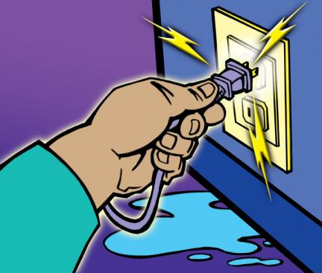

Get a laptop and go to www.nbpower.com

- Once on the site locate “Safety and Learning” and find “Tips for Kids”

- Read through the list of safety tips when around electricity

- Your task will be to create a brochure in Smart Notebook or Microsoft Word

- You should highlight 5 main safety tips in your brochure

- Brochures should include pictures and graphics either from the gallery in notebook or from the Internet.

