Day Four Home Learning:
Reading:
Dreamscape or Squigglepark for 20 minutes, if you don’t remember password just contact me.https://game.playdreamscape.com/
https://play.squigglepark.com/squigglepark/index.html
https://game.playdreamscape.com/
Please read 30 minutes silently or orally with an adult.
For Writing today, write a procedural (How to) piece on how to make your favorite sandwich or snack food. It needs to be something you prepare.

Math Grade 4
Login to Dream box for 20 minutes, I will be able to see your progress. If you don’t remember your password just send me a message and I’ll get it for you.
https://play.dreambox.com/login/knjs/63ng

- Review multiplication and division facts to 5X10.
- Make clocks to show the following time on an analogue and digital clock.
- 2:45, 3:15, 5:55, 7:35, 9:25 and 12:30
- Play a cool math game on Making Ten
- https://www.coolmathgames.com/0-plus-10
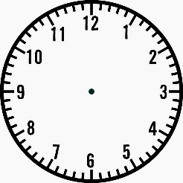
French Grade 3: Watch video on Hello Bonjour and practice phrases at home with family.https://www.youtube.com/watch?v=atNkI6QFZ50
Grade 4(Nov. 1-5th), Mrs. Taylor would like you to work on Level 1 and module 4 on Flora (School) Listen and read story and choose three activities
https://flora.nbed.nb.ca/
Art: Draw a shade name with crayons, or color pencils, post picture on our Facebook page.
https://thatartteacher.com/2020/08/22/colored-pencil-name-design/

