Day1 | Day 2 | Day 3 |  | Day 4 | Day 5
Victoria Day!!!
30 min Math | 30 min Math | 30 min Math |  | 30 min Math | 30 min Math
Reflex/Dream Box or | Reflex/Dream Box or | Reflex/Dream Box or |  | Reflex/Dream Box or | Reflex/Dream Box or
https://play.dreambox.com/login/knjs/63ng  https://www.reflexmath.com  Victoria Day!!! | https://play.dreambox.com/login/knjs/63ng  https://www.reflexmath.com  Science/Math  The Challenge!!  Upcycling is taking a product or material that you would generally throw away and turning it into something new and useful. This helps keep non – biodegradable junk out of landfills and our ocean. Check out this amazing second hand mall. LINK:  https://www.bing.com/videos/search?q=you+tube+world%27s+first+recycle+mall&docid=608002476437998674&mid=37C28A738DCBD5753A6537C28A738DCBD5753A65&view=detail&FORM=VIRE  Your challenge is to find some items around your house that are broken or no longer being used and create something new and useful.  Please post photo on class Facebook Page so we all can share our great ideas! | https://play.dreambox.com/login/knjs/63ng  https://www.reflexmath.com  Math:  Continue to work on “Upcycling” project from Day 2  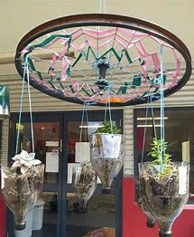  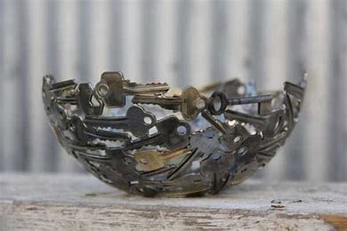 | https://play.dreambox.com/login/knjs/63ng  https://www.reflexmath.com  Symmetrical Shapes Outcome SS5  A line of symmetry divides a shape into two parts that are congruent. When a line of symmetry can be drawn on a shape, it has symmetry.  Complete two handouts determining lines of symmetry. Pages will be included on Teacher page as a document.  Play game on ABCYA Physics Symmetry ll  Link:  http://www.abcya24.com/physics-symmetry-ii.html |  | https://play.dreambox.com/login/knjs/63ng  https://www.reflexmath.com  Math Ninja!!  Being a Super Hero means you must be fast! Let’s practice by running around your house as fast as you can and have someone time how many seconds it takes you! Repeat 5 different times and record each one. Once you have recorded each of your 5 laps, put your times in order from your least time to your greatest time? What was your fastest? What was your slowest?
30 min Literacy | 30 min Literacy | 30 min Literacy |  | 30 min Literacy | 30 min Literacy
Brain pop  Link:  https://www.brainpop.com/  Victoria  Day!!! | Read the attached document on the teacher page called, “Shapes in nature” a reading selection containing a follow up question sheet. | Listen to: How to draw a cartoon character  Link: How to draw a cartoon character!!  https://www.bing.com/videos/search?q=Mr+Maynerry+drawing+cartoon+characters&&view=detail&mid=1359E72E34E891B6BEF71359E72E34E891B6BEF7&&FORM=VRDGAR  Practice drawing characters for a cartoon of favorite characters tomorrow. |  | Read from the NB library site:Tumblebooks!!  https://swv44svru02.gnb.ca/login?url=http://www.tumblebooklibrary.com/auto_login.aspx?U=nblib&P=libra  013287563 is my number you may use if you don’t have a library card.  Comic Strip  Choose your favorite character from a book from Tumblebooks or a book you have read or are reading. Create a comic strip to show the events in order or a favorite character scene. | Your choice of book today!!  Continue to work on Day 4’s How to make a comic strip. Complete strip and colour. Post a picture of your strip on our Facebook page so that we can read your cartoon strip.
30 min Reading | 30 min Reading | 30 min Reading |  | 30 min Reading | 30 min Reading
 | Read to an adult to improve fluency  Use the story, “Shapes in Nature” to answer the sheet of attached questions. | Continue to work on the attached Question sheet for the story “Shapes in nature”  Link for article and questions, will be an attached document on Teacher’s page. |  | Also, how to make a comic strip!! Link:  https://www.bing.com/videos/search?q=you+tube+making+a+comic+strip+for+kids&docid=608022083000861386&mid=86FE081F7DACD31DDD5A86FE081F7DACD31DDD5A&view=detail&FORM=VIRE
30 min Wellness | 30 min Wellness | 30 min Wellness |  | 30 min Wellness | 30 min Wellness
http://nsee.nbed.nb.ca/teacher/miss-downey | http://nsee.nbed.nb.ca/teacher/miss-downey | http://nsee.nbed.nb.ca/teacher/miss-downey |  | http://nsee.nbed.nb.ca/teacher/miss-downey | http://nsee.nbed.nb.ca/teacher/miss-downey
 | FN Story/Activity  http://nsee.nbed.nb.ca/teacher/ms-mountain |  |  |  | Fun Friday Art Lesson  Your Trash, Your Treasure  Create a name plate using old materials such as: nails, utensils, buttons, handles, jewelry, parts from old electronics, fabric, etc.  