Day1 | Day 2 | Day 3 | Day 4 | Day 5
30 min Math | 30 min Math | 30 min Math | 30 min Math | 30 min Math
Reflex/Dream Box orhttps://play.dreambox.com/login/knjs/63ng  https://www.reflexmath.com/ | Reflex/Dream Box or  https://play.dreambox.com/login/knjs/63ng  https://www.reflexmath.com/ | Reflex/Dream Box or  https://play.dreambox.com/login/knjs/63ng  https://www.reflexmath.com/ | Reflex/Dream Box or  https://play.dreambox.com/login/knjs/63ng  https://www.reflexmath.com/ | Reflex/Dream Box or  https://play.dreambox.com/login/knjs/63ng  https://www.reflexmath.com/
A habitat is the natural home or environment of an animal, plant, or other organism. Deserts, oceans, mountains and forests are some types of habitats. Many are threatened by climate change and human activity.  Your challenge this week is to measure out 1 square meter of land of your choice and observe the biodiversity you see in just this chunk of Earth. The lawn, the garden, in the woods, shaded sun kissed. Record your findings in a paragraph. | Continue to work on Habitat lesson from Day 1 | Estimation Fun  You’ll need a clear jar. Find some pebbles outside and place 5 of them in the bottom of your jar. Estimate how many pebbles you’ll need to fill the jar. Find enough pebbles (around the same size) to fill your jar. How close was your estimate? You can try this activity inside with materials such as macaroni or candy. | Math Ninja!!!  Nature Ninjas need yummy snacks for playing outside. You have 30 dollars to buy snacks for the week. Using an online grocery flyer, or one at home in the recycling, create a shopping list for your snacks. Remember that some items are taxable, so don’t forget to estimate the tax too. | Symmetry Search  Look for 5 examples of symmetry in nature. Find five examples, and explain to a parent or sibling how many lines of symmetry are present in each one.
30 min Literacy | 30 min Literacy | 30 min Literacy | 30 min Literacy | 30 min Literacy
Respond to Reading
Favourite part and why?
30 min Reading | 30 min Reading | 30 min Reading | 30 min Reading | 30 min Reading
Your choice of book from  Tumblebooks- or a book of your choice  https://swv44svru02.gnb.ca/login?url=http://www.tumblebooklibrary.com/auto_login.aspx?U=nblib&P=libra  013287563 is my number you may use if you don’t have a library card.  What is the main idea of the text? In other words what is the passage about? Write the explanation of the main idea in a short paragraph. | username NSEE  Password cobra2020  Choose the topic of Science  Read 30 minutes on the topic of ”Recycling”  Read: Recycling, Plastic, Waste Management and Water Pollution.  Each story is about 5 minutes long  Using the stories read on “Recycling”, write a paragraph on what you learned about recycling and waste management. | Book of your choice  Read to a family member  Ask who the section was about and what happened. Retell using the 5 “W’s”, who, what happened, where, when and why did the character do what he/she did. | Using the topic of recycling from Day 2 write an opinion paragraph from the readings.  OPINION  What is your opinion on the topic you read about? (RECYCLING)  How do you feel about the issue? Please give three reasons with detail. | Book of your choice  Write a summary about what your story today is about, Include the main ideas, facts, and details from the story.  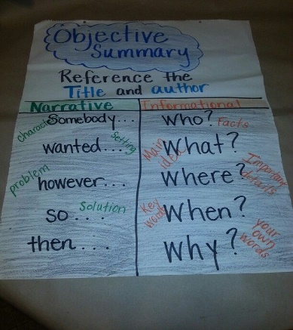
30 min Wellness | 30 min Wellness | 30 min Wellness | 30 min Wellness | 30 min Wellness
 | http://nsee.nbed.nb.ca/teacher/miss-downey | http://nsee.nbed.nb.ca/teacher/miss-downey | http://nsee.nbed.nb.ca/teacher/miss-downey | http://nsee.nbed.nb.ca/teacher/miss-downey
 | FN Story/Activity  http://nsee.nbed.nb.ca/teacher/ms-mountain |  |  | Fun Friday Art Lesson  How to draw an owl.  https://www.youtube.com/watch?v=wsDQNYAOitU  Non technology choice, draw a tree as a habitat and add plants and animals to the picture that make the tree their home.

