Day1 | Day 2 | Day 3 | Day 4 | Day 5
30 min Math | 30 min Math | 30 min Math | 30 min Math | 30 min Math
Reflex/Dream Box or | Reflex/Dream Box or | Reflex/Dream Box or | Reflex/Dream Box or | Reflex/Dream Box or
https://play.dreambox.com/login/knjs/63ng  https://www.reflexmath.com  Science/Math  Nature Ninja!!  What do you look like as a Ninja Hero? Use as many different shapes as you can to draw a picture of yourself. The more shapes you use, the more powerful you become. What does your costume look like?  Shapes examples  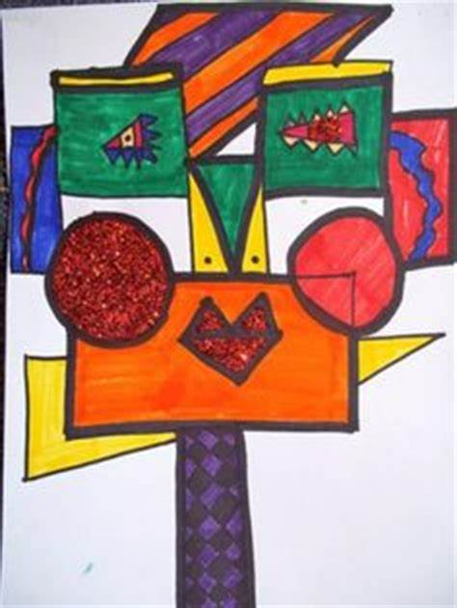 | https://play.dreambox.com/login/knjs/63ng  https://www.reflexmath.com  Continue to complete Nature Ninja activity from Day 1 | https://play.dreambox.com/login/knjs/63ng  https://www.reflexmath.com  Science/Math  Baking Fun!!  Your body needs fuel. With the help of an adult, bake a favourite recipe. Practice using a clock (to keep track of baking time), measuring cups and measuring spoons. If you’re making cookies practice writing a repeated addition or multiplication sentence after you have arranged the cookies on the baking sheet. | https://play.dreambox.com/login/knjs/63ng  https://www.reflexmath.com  Go on a nature hike and search for items such as pinecones, rocks, pebbles, sticks, and leaves. When you’re done, create a bar graph of your items. What did you find the most of? Least? How many altogether? | https://play.dreambox.com/login/knjs/63ng  https://www.reflexmath.com  Imagine you have 100 dollars to spend on the weekly groceries. Use online flyers or some from you’re recycling to help make up your list. Keep track of how much you spend. Will you have any left over? Will you be throwing away food?
30 min Literacy | 30 min Literacy | 30 min Literacy | 30 min Literacy | 30 min Literacy
 |  |  | Read out loud to improve fluency. | Your choice of book today!!
30 min Reading | 30 min Reading | 30 min Reading | 30 min Reading | 30 min Reading
Tumblebooks- or a book of your choice  https://swv44svru02.gnb.ca/login?url=http://www.tumblebooklibrary.com/auto_login.aspx?U=nblib&P=libra  013287563 is my number you may use if you don’t have a library card.  Create an Acrostic poem for Mom(5 steps)  - Decide what to write about  - Write your word down vertically. Mother/Grammy/Nana  - Brainstorm words or phrases that best describe your mom/ grandmother  - Place brainstormed words or phrases on the lines that begin with the same letter.  - Fill in the rest of the lines to create a poem. It doesn’t have to rhyme!  Link: for a short video  https://www.youtube.com/watch?v=ybexYTzmZ5Y | Read to an adult to improve fluency  Continue to work on Acrostic poem for mom. Remember if you want help look at video!! | Tumblebooks- or a book of your choice or  Level  013287563 is my number you may use if you don’t have a library card.  Make a list of things you did this week to pass the time that you wouldn’t have done normally. Perhaps a jigsaw puzzle, game, cooking, etc.  -How many can you come up with?  - Get a friend or family member to make a list too and compare.  -Estimate how long it would take to complete each of these tasks. | There is a lot of research that proves that helping others helps you feel better.  Think of something you could do to help one of your family, friends or neighbours during this difficult time. Do it and then write to describe what you did and how it made you feel. | Make a list of things that you would like to persuade (convince) someone at home that you would like to do (stay up late).  Pick from your list a persuasive writing piece include 2 or 3 reasons why you should be able to do it. Don’t forget your hook and a great ending!!
30 min Wellness | 30 min Wellness | 30 min Wellness | 30 min Wellness | 30 min Wellness
http://nsee.nbed.nb.ca/teacher/miss-downey | http://nsee.nbed.nb.ca/teacher/miss-downey | http://nsee.nbed.nb.ca/teacher/miss-downey | http://nsee.nbed.nb.ca/teacher/miss-downey | http://nsee.nbed.nb.ca/teacher/miss-downey
 | FN Story/Activity  http://nsee.nbed.nb.ca/teacher/ms-mountain |  |  | Fun Friday Art Lesson  Create a Mothers’ Day Card to give to mom on Sunday!!

