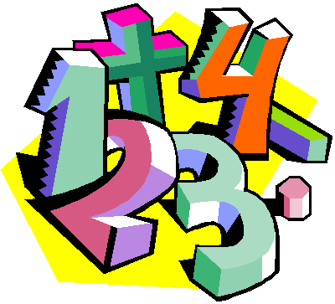
Suggestions for Home Learning Week 1 (April 6th to 9th)

Grade 5 Math

 | With No Technology | With Technology
Multiplication & Division  Practice | Use a deck of cards to play Multiplication Snap. You can play by yourself by picking two card and multiply them or you can play with a family member by each of you revealing a card to multiply.  Use flash cards that you can print or make yourself to practice facts.  Get someone to make up 12 questions for you to solve. | Study your math facts from 1 to 9. You should be able to do 12 questions in one minute.  www.multiplication.com  https://www.abcya.com/search/?term=multiplication&type=game&id=0
Math  Review | Data & Probability Review: Students can ask questions such as “What is your favorite TV show?” to your family member. Use this data, to create a tally and a bar graph.  Telling Time Review: Students can practice telling time using digital and analogue clocks. Students can also create a daily family schedule to follow. | A great website to use is Dreambox. This is free for parents to sign up their kids for 90 days. This site reviews all math concepts that we have covered this year. It will take you 5 minutes to sign up and your child will be able to work at their own pace for the rest of the school year to review and learn new concepts.  www.dreambox.com/at-home
Something New | Equivalent fractions are different fractions that name the same number.Draw shapes of the same size then divide them into equal parts  2/3  4/6 | This week, continue to explore the wonderful world of fractions. Fractions can be named in different ways. Check out this video to help you understand.  http://www.learnalberta.ca/content/me5l/html/Math5.html  Choose Lesson: Equivalent Fractions  https://www.youtube.com/watch?v=0JUbXN5accU
A Bit of  Math Fun | Make your own crossword puzzle:  - 1. Make a word list with the clue and the answer. For example, “The name of my school….NSEE”.  - 3. Use the answers to create your own puzzle. It would help to use grid paper (or you can make your own)  - 4. Make your puzzle, write out the clues and give it to someone to solve. | Tangram Puzzles: We had some fun with tangrams the other week. Here is a site to print out a set of tangrams to use at home to help develop spatial awareness.  https://www.myhomeschoolmath.com/Worksheets/Tangram-Animals.pdf  And here is a site to explore online. https://www.abcya.com/games/tangrams
Extra practice sheets you can print if you really really want them!

Data & Probability Review: https://www.easyteacherworksheets.com/pages/pdf/math/graphing/bar/double/6.html
Telling Time Review: https://www.k5learning.com/worksheets/math/grade-3-elapsed-time-15-minute-increments-f.pdf
Equivalent Fractions: https://www.k5learning.com/worksheets/math/grade-4-writing-equivalent-fractions-a.pdf

