B | I | N | G | O
Have a karaoke night. Children can sing their favorite songs. Give compliments for each person’s attempts. | Read a book while sitting in the sun. | Do 10 min of Just Dance or Go noodle (Click the  Links tab on my  Page) | Put on some music and dance for five minutes. | Organize a closet and make a bag of items to donate to others.
Play charades. Include some actions to demonstrate emotions. | Make a list of 5 things that you are grateful for. Share with someone. | Draw a picture of a PE Game you would like to play when we get back. (Send me a picture) | Do 10 minutes of Yoga. (Click the  Links tab on my  Page) | Practice your  Push-ups.  (Aim for 20)
Play outside for at least 30 minutes. | Have a Family Board game day/night. | FREE | Take turns humming songs and have others try to guess the name of the song. Be patient with everyone! | Call a friend or family member to check in.
Make an obstacle course to practice on. Then send me a picture at  Marcy.downey  @nbed.nb.ca if  you can. | Practice your jumping jacks. | Use some chalk, rocks or tape to create happy messages on your driveway!  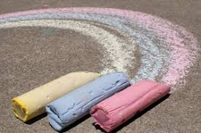 | Tell someone in your family 5 things that they  can do to keep healthy. | Call a relative to get a recipe for their dish that you love!
Practice your  Frog hops around the house. | Win 10 games of Rock, Paper, Scissors. | Pick your favorite activity and do it again. | Practice hopping on one foot. | Get 60 minutes of Physical Activity in a day. (Can be broken) up throughout the day)
Jr. Cobra Bingo
Mark with an “X” the different activities you complete over the course of the week. Let’s try a couple of activities per day. How many different variations of BINGO can you get?

