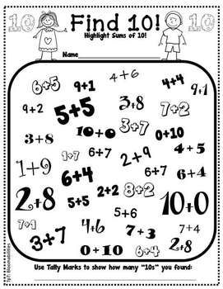
Name: ____________________ Date: _____________________

Using Making 10 Mental Math Strategy to Add Larger Numbers.

Please complete table. Study for this week. Quiz on Friday.

Ways to Make 10 | Ways to Make 100
- 1 + 9 = 10 | 10 + 90 = 100
- 2 + 8 =
- 3 + 7 =
- 4 + 6 =
- 5 + 5 = | 50 + 50 = 100
- 6 + 4 =
- 7 + 3 =
- 8 + 2 =
- 9 + 1 =
- 10 + 0 =

