NSEE will be taking part in bullying awareness week which is held Nov. 13-19th. The theme this year is “STAND UP”. Friday November 18th will be BLUE FRIDAY. The color blue represents Former Canadian Prime Minister Lester B. Pearson who won the Nobel Peace Prize for his work in establishing United Nations Peacekeepers, who wear blue as a symbol of peace as they perform their work around the world.
We will be kicking off the week with an assembly led by our Peace Makers on Monday Novmber 14th. The message of “STANDING UP” to bullying will be promoted at both the class and school level throughout the week with various activities. Students are asked to come to school wearing blue to help promote the message of peace on Friday November 18th.
Our Commitment
North & South Esk Elementary (NSEE) does not tolerate bullying in any form. All members of the NSEE Community are committed to ensuring a safe and caring environment which promotes personal growth and positive self esteem for all.

We will be reviewing our school pledge with students during the whole month of November.
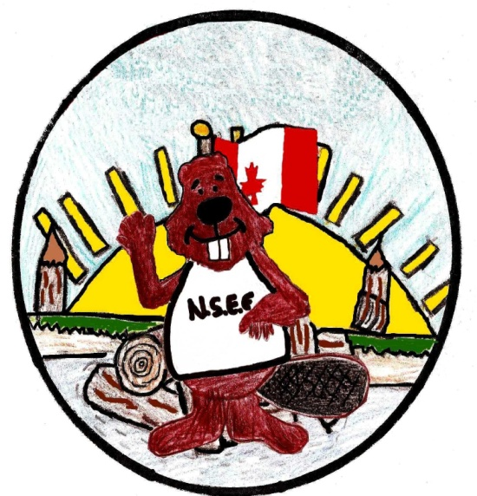
School Pledge
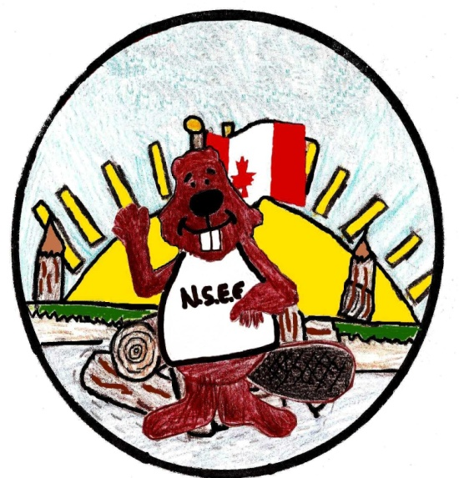
· I do my part to make NSEE a great place to learn.
· I do not bully others; I treat adults and students with
respect and kindness.
· I do what’s right and report bullying. I don’t allow
bullying at my school!

NESSY is too cool to bully,
how about you?
For more information please check out - www.bullyingawarenessweek.org

